**Revision for EC2-AMI-EBS 23-03-2024 ( Saturday)**

Q1 - How these subnets calculation is happening behind?

Q2 - There are almost 7-8 steps to create a VPC, is there is any other way around to get my work fully automated.?

Q3 - Do I really need to create a VPC every time whenever I go to the new region for testing?

Q1

Subnet Calculation formula >>>> 2 ^ (32 - ??) = 2 ^ ?? = ???

10.0.0.0/24

2 ^ (32 - 24) = 2 ^ 8 = 256

10.0.0.0/26

2 ^ (32 - 26) = 2 ^ 6 = 64

10.0.0.0/16

2 ^ (32 - 16) = 2 ^ 16 = 65,536

10.0.0.0/28

2 ^ (32 - 28) = 2 ^ 4 = 16

Default VPC Vs Custom VPC

EC2 >>> VM

OS >>> AMI

Storage (HDD) >>>> EBS

CPU/RAM >>>>> Instance Type

Security >>>> SecurityGroups

User name & PWD >>>>>

Initial fixed username &&&& PWD will be encrypted and stored in the Key-Pair

Win >>> Administrator

Amazon Linux or RHEL >>> Ec2-user

CentOs >>> CentOS

etc.....

1 - How to launch and connect a Windows EC2

2 - How to launch and connect a Linux EC2

3 - How to troubleshoot your EC2

4 - How to connect EC2 which is launched in public Subnet

5 - How to connect EC2 which is launched in private Subnet

6 - How to add a custom user in Win EC2 and Linux EC2

7 - How to upgrade Instance Type

8 - How to upgrade EBS

9 - How to copy my EC2 from one region to another region

10 - How to take a backup of my EC2

11 - If I lost my key-pair, how to login the server?

12 - Public IP Vs Private IP Vs EIP

etc

https://aws.amazon.com/ec2/instance-types/

Test-Franfruit-key-pair

Dev-Franfruit-key-pair

Acc-Franfruit-key-pair

Prod-Franfruit-key-pair

Go to EC2 >>>

- Launch a EC2

- Name and tags >>> Give your EC2 name >>> windowsec2

- Application and OS Images (Amazon Machine Image) >>> Choose windows AMI

- Instance type - t2.micro

- Key pair name - Click on Create new key pair >>> Create and that will be downloading in to your local machine

- Network settings - Edit >>>

- Choose your Custom VPC

- Choose any your public Subnet

- Enable - Auto-assign public IP

- Firewall (security groups) - Leave everything as it is for now

- Configure storage - 30 GiB

Review and "Launch Instance"

you have to make sure your instance state turn into "Running"

Private IP Vs Public IP Vs EIP

your laptop is already having a RDP if its a windows laptop

Go to your laptop >>> Search >>> Remote desktop connection

OR

Open RUN >>> MSTSC

COpy your Public IP from your EC2 console and give it there >>>> Then connect >>> if you see the login screen to enter user name and PWD

Meaning - your EC2 is responding and its working as it should.

user name - Administrator

PWD ??

Go back to your EC2 console >>>> Click on Connect in your right top corner >>>> Choose RDP Client >>> Here you can find "Password >>>> Get password"

Click on "Get password"

NOw it will ask you to upload your private key file

Upload and decrypt the PWD

EC2 is not connecting ?

1 - Instance State

2 - Make sure you are using public IP not private IP

3 - Make sure you have launched your EC2 on top of Public Subnet only

4 - Make sure this public subnet is associated with the public RT or not

5 - Make sure your Public RT is having IGW configured at the routes or not

6 - Make sure your SG is opened to your IP or anywhere with the RDP or SSH Port.

Cleanup your lab and we will continue

1 - How to launch and connect a Windows EC2

2 - How to launch and connect a Linux EC2

3 - How to troubleshoot your EC2

4 - How to connect EC2 which is launched in public Subnet

5 - How to connect EC2 which is launched in private Subnet

6 - How to add a custom user in Win EC2 and Linux EC2

7 - How to upgrade Instance Type

8 - How to upgrade EBS

9 - How to copy my EC2 from one region to another region

10 - How to take a backup of my EC2

11 - If I lost my key-pair, how to login the server?

12 - Public IP Vs Private IP Vs EIP

etc

23.03.2024

EC2 >>> Private IP (Subnet IP Range) >>>>> Internal Communication (Within VPC) >>> Static IP

>>> Public IP (Amazon Open IP Pool) >>>> External Communication (Outside of the VPC) >>>>> Dynamic in Nature >>> Stop and then start >>> your IP will be changed

(It never changes when you just restarted)

>>> EIP >>>>> (Amazon Open IP Pool) >>>>> As long as it is associated with your Running EC2 >>>> NO Charges >>> Whenever this IP is released or associated with Stopped EC2 then it will be chargeable.

EIP Charges

- When your EC2 Instance is stopped and your EIP is still associated

- When your EIP is free and NOT associated with EC2

EIP NO Charges

- When your EC2 Instance is Running and your EIP is still associated

Private IP Vs Public IP Vs EIP

USD 0.0045 per hour

Windows >>> OS >>> Root >>> min 30 Gib

Linux >>>> OS >>>> Root >>>> Min 8Gib or 10 Gib

30 GiB EBS free for you

ttps://docs.aws.amazon.com/AWSEC2/latest/UserGuide/managing-users.html

Create a new Windows EC2 if not already existed

Try to login the server and follow the below steps (if you cant able to login, follow above checklist to troubleshoot)

How to change the Administrator PWD

- Search >>> Computer Management

- Local Users and Group >>> users >>> Administrator >> Right Click >>> Set Password >>> Proceed >>> Give your fav PWD and repeat >>> DONE

Now you have successfully reset your Administrator Password

Try to re-login with that new PWD

Create a New Users

right CLick >>> New User

Give the user name and fill all other details and create

This user doesnt have any permissions to login

Groups >>>> Administrator >>> Right Click >>> Properties >>> add >>> give your new user name >>> Check names >>> OK >>> Apply >>> OK

NOw this new user has full Admin access

Login as that new user

How to launch the windows EC2

How to reset Administrator PWD

How to create a new user and login with new user name and PWD

Windows EC2

30Gib >> Root Vol

T2.micro >>> 1 CPU & 1 GiB RAM

Upgrade Instance Type (Chargeable)

1 - Make sure your EC2 is stopped

2 - Choose your EC2 >> Actions >>> Instance Settings >>> Change Instance Type >>> Choose your preferred Instance Type >>> apply

3 - Start your EC2 and Validate

Want a Additional Volume (Chargeable)

you can go to your EC2 Dashboard >>> Elastic Block Store >>> Volume >> Create Volume >>> GP3 >>>

Size >> 1 GiB

Availability Zone >> as same as your EC2 Availability Zone

Leave all the options as it is.

Create a Volume

Then

Select your Volume >> Actions >>>> Attach VOlume

Now you can choose your EC2 and Choose the Volume ID and attach

Now you can go back to your EC2 >> Computer Management >> Disk Management >>> And you can see your new volume

By default your Disk is offline

Click on Left portion where you can see Disk1 >>> Right click >>> Online

Now Disk is online >>> next step >>> Initialize disk >>> right click at the same place

Now your disk is online and initialized

Now right click on the size of your disk and make it as a new volume

Right click >>> New simple Volume

Next >> Next >> next >> finish

I want to upgrade my EBS volume size

Go to your EBS Volume >> Select it >> Action >>> Modify Volume >>> size from 1 GiB to 2Gib

Leave all the options as it is >>>>> Modify >>>> Modify

Volume upgraded at the AWS Console level

But it doesnt reflect inside the OS

Go back to your EC2 >>> Computer Management >> actions at the top >>> refresh

Now you can see your unallocated

Right click on the volume >>> Extend VOlume >>> next >>> next >>> finish

you have successfully Upgraded your EBS Volume Size

Cleanup this EC2 and make sure your additional Volume is also deleted

**Handson VPC , How to Connect and upgrade EBS Volume in Windows EC2 Instance**

**AWS - VPC (Virtual Private Cloud) | Public, Private subnets, IGW,**

**Go to AWS Console and Create VPC**

**AWS VPC (Virtual Private Cloud) from scratch, We will also see what are :-**

**and also how to create all these!!!**

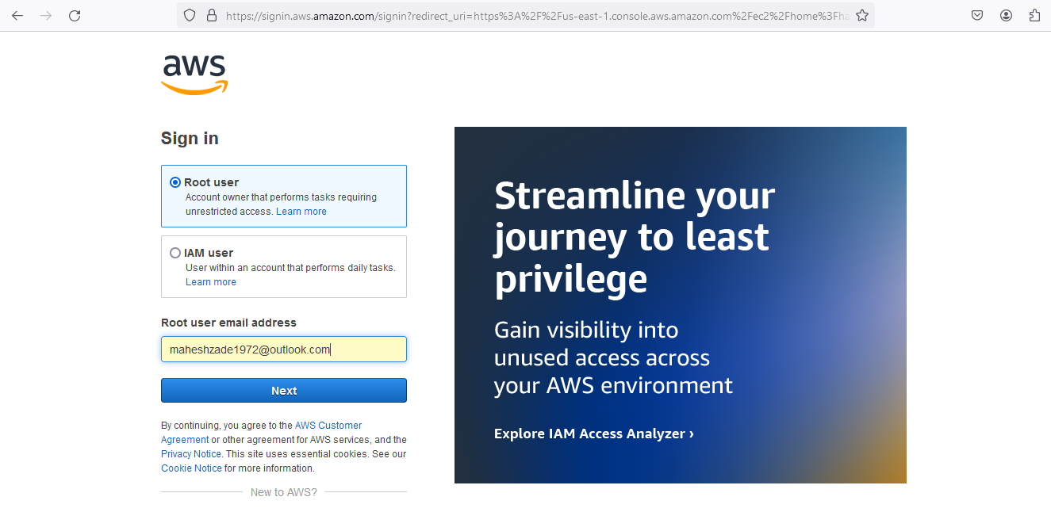

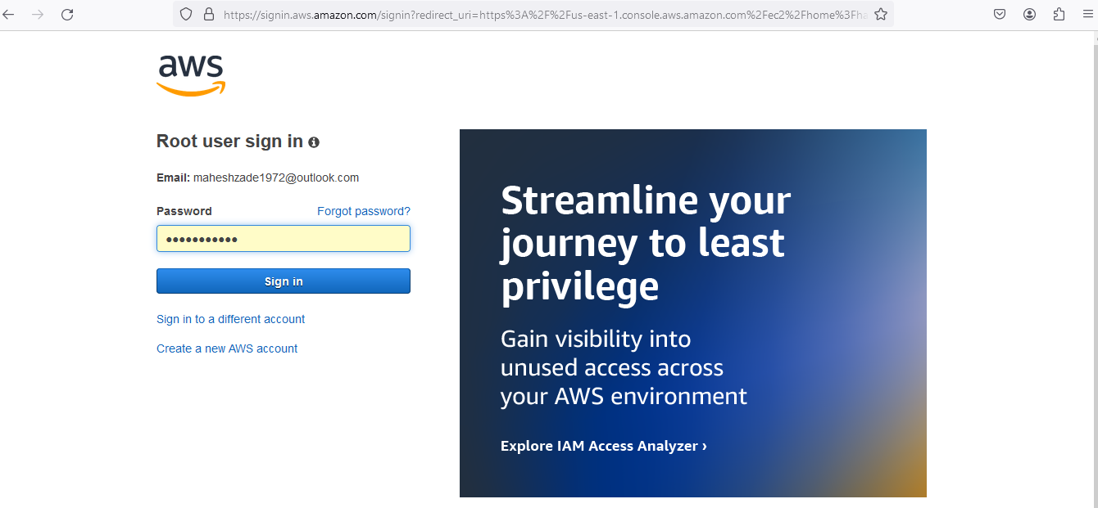

**Go to VPC and Select the Region N Virginia ( Any Region )**

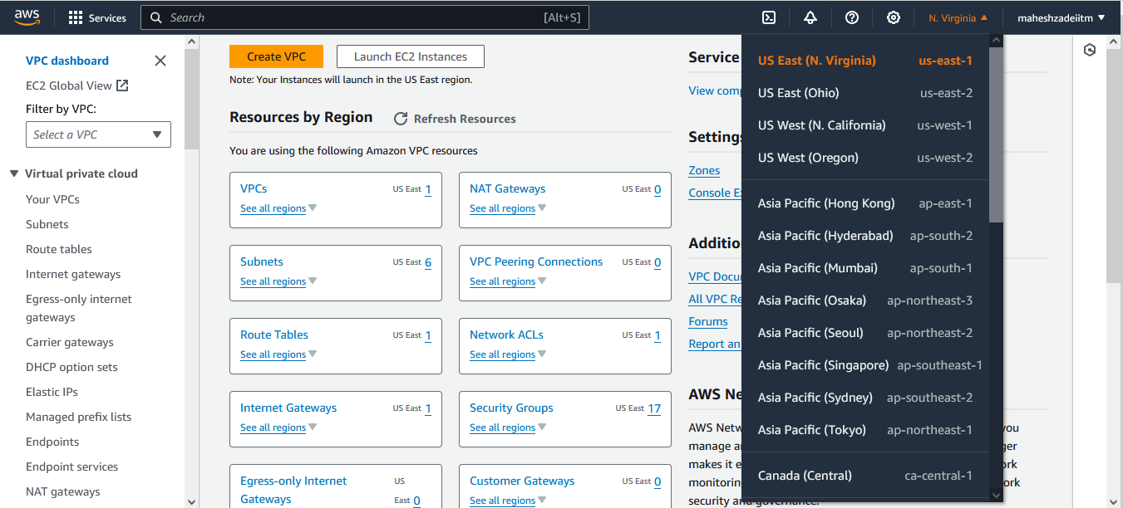

**Click Create VPC**

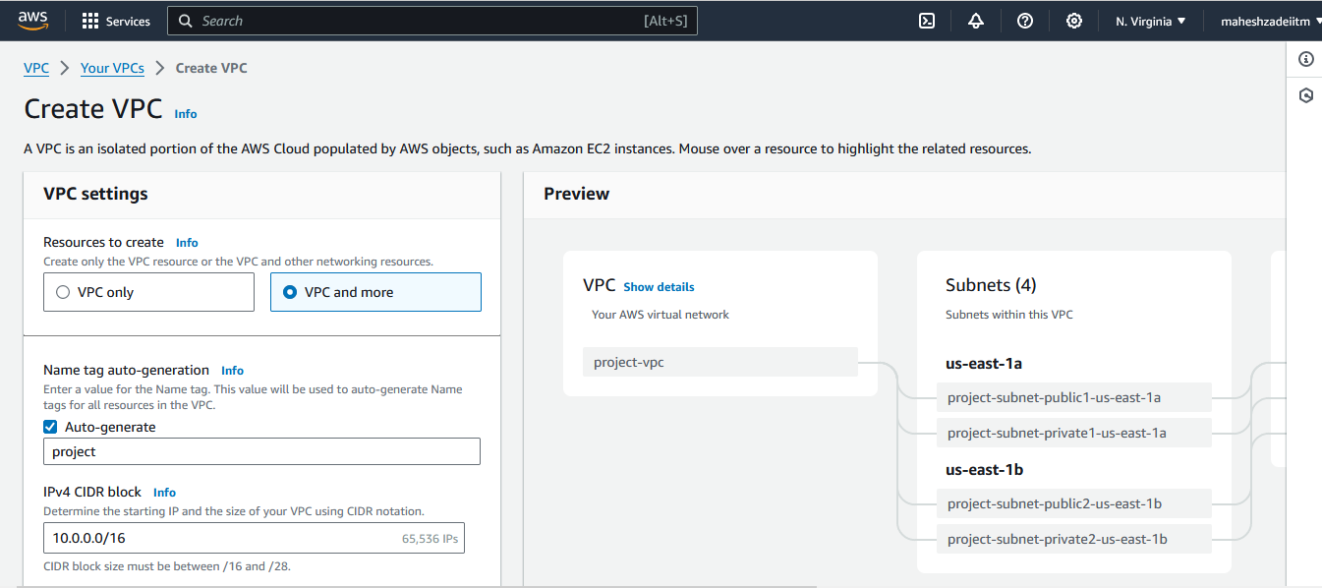

**Click on Create VPC only**

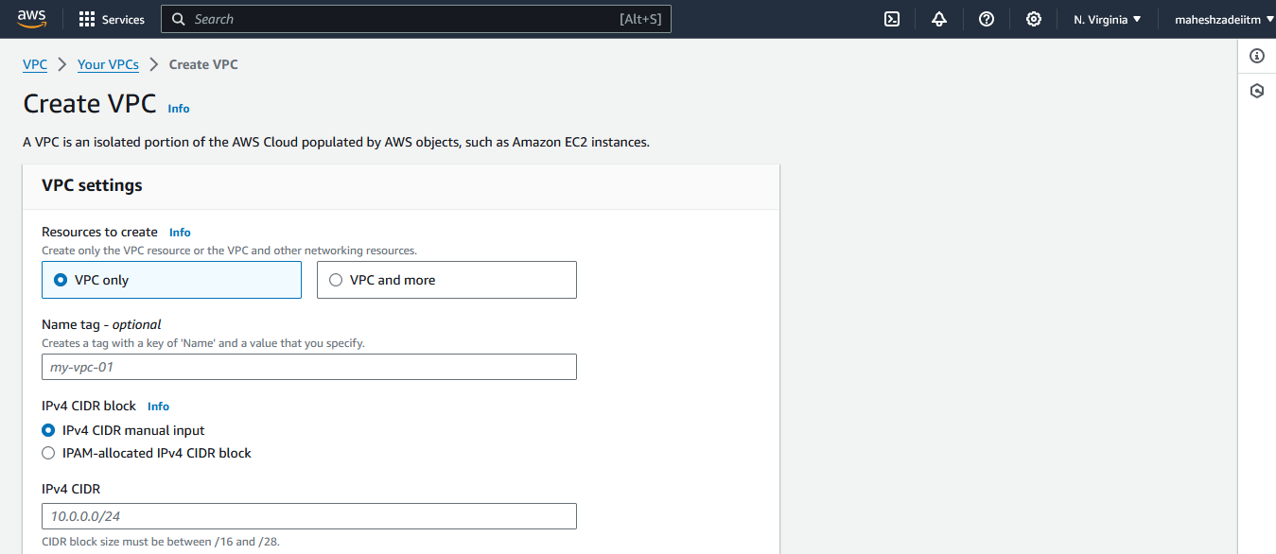

**Tag name and put the CIDR value 10.0.0.0/24**

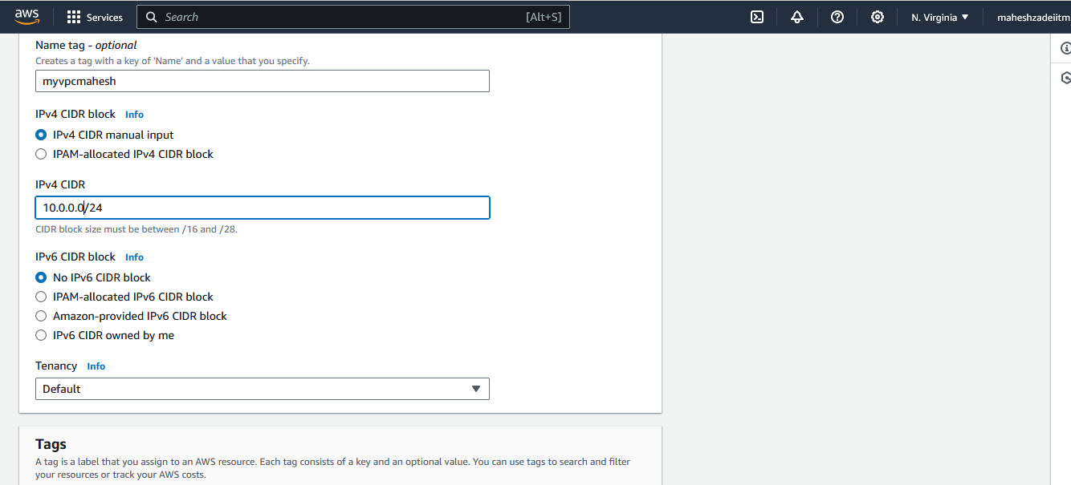

**Click rest as it is and click on Create VPC**

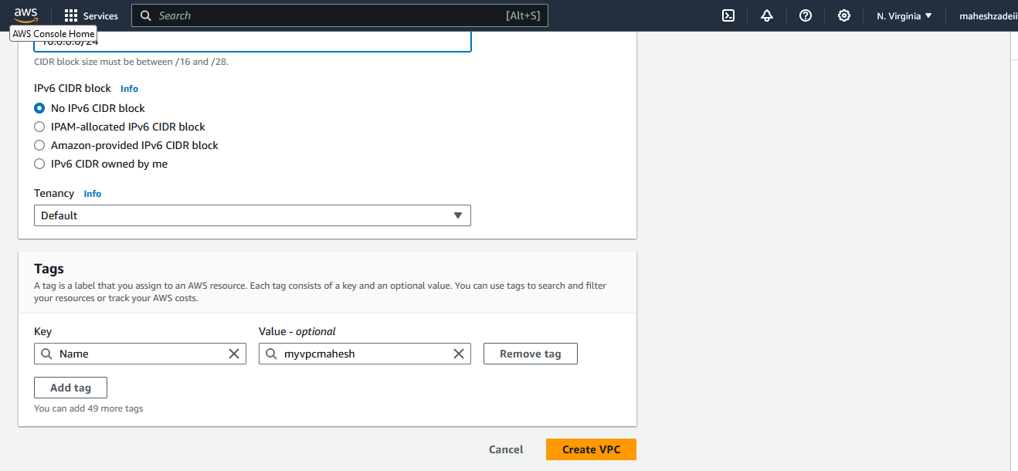

**VPC Created**

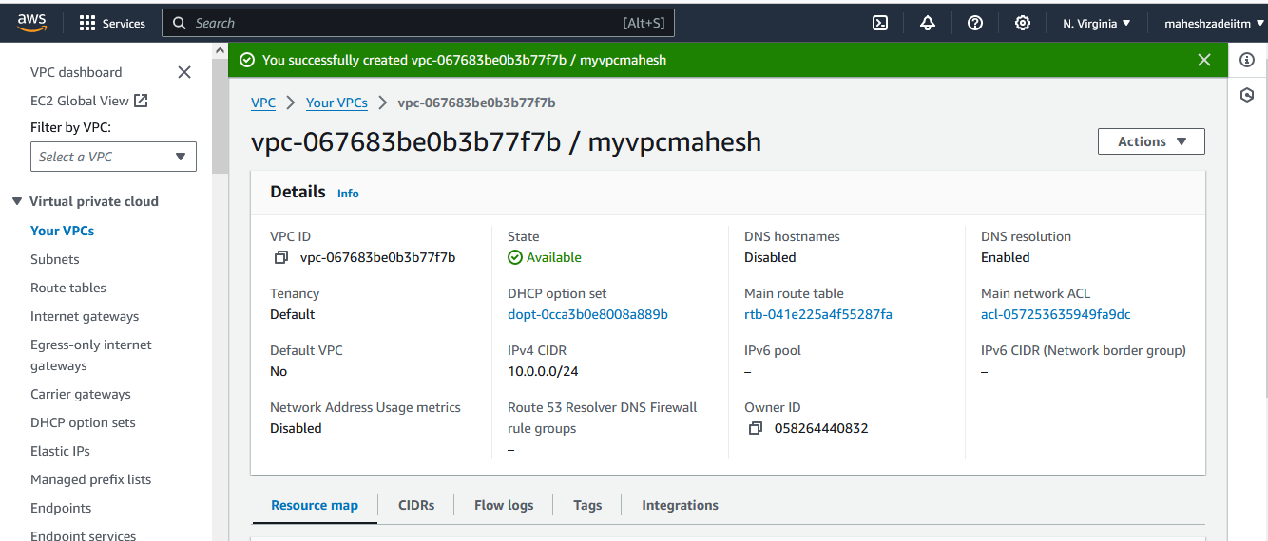

**Go to your VPC check it is available**

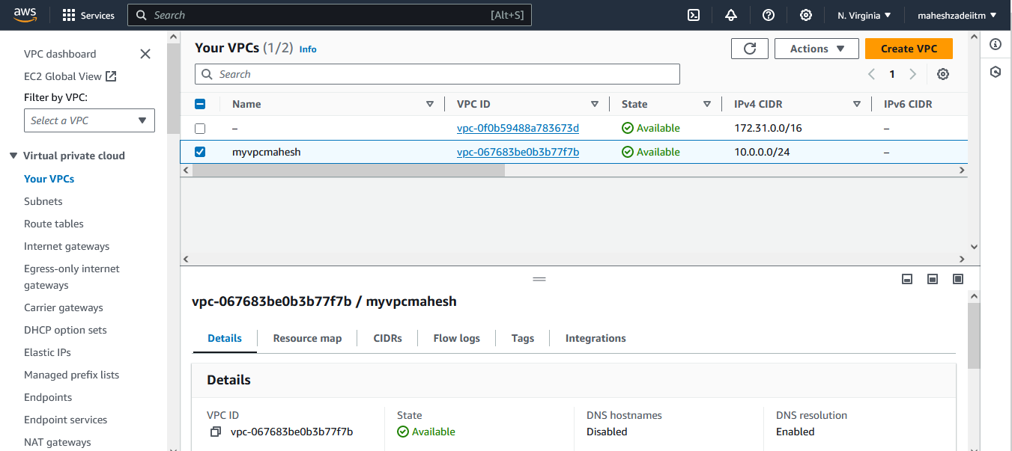

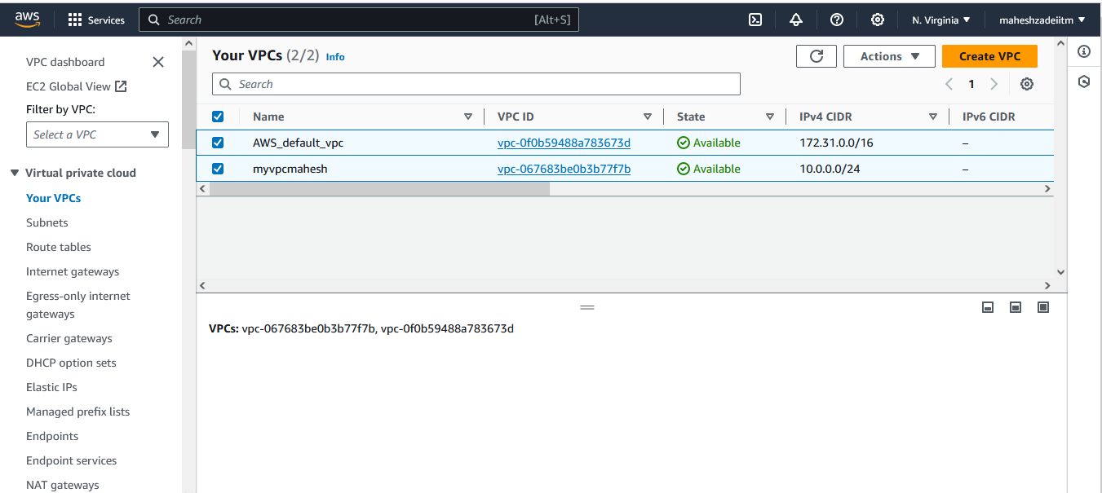

**Now Go to below link for the subnet IP calculator**

[**https://www.davidc.net/sites/default/subnets/subnets.html**](https://www.davidc.net/sites/default/subnets/subnets.html)

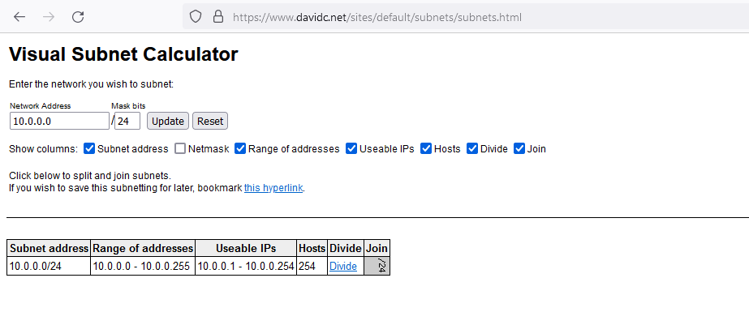

**Then Click on divide in four block of Subnet for getting the IP range**

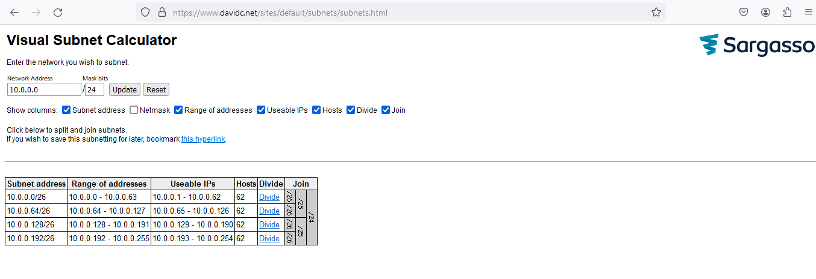

**10.0.0.0/24**

**32-24 = 8**

**2 ^ 8 = 256-2( IP reserved ) 254**

**Example**

**And if you take the subnet range**

**10.0.0.0/26**

**32-26=6**

**2 ^ 6 = 64 -2 ( Reserved) 62**

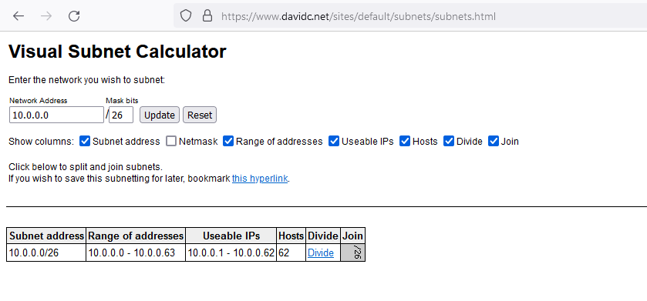

**Once you create the VPC Route Table Automatically created so lets give the our Name RT-Mahesh**

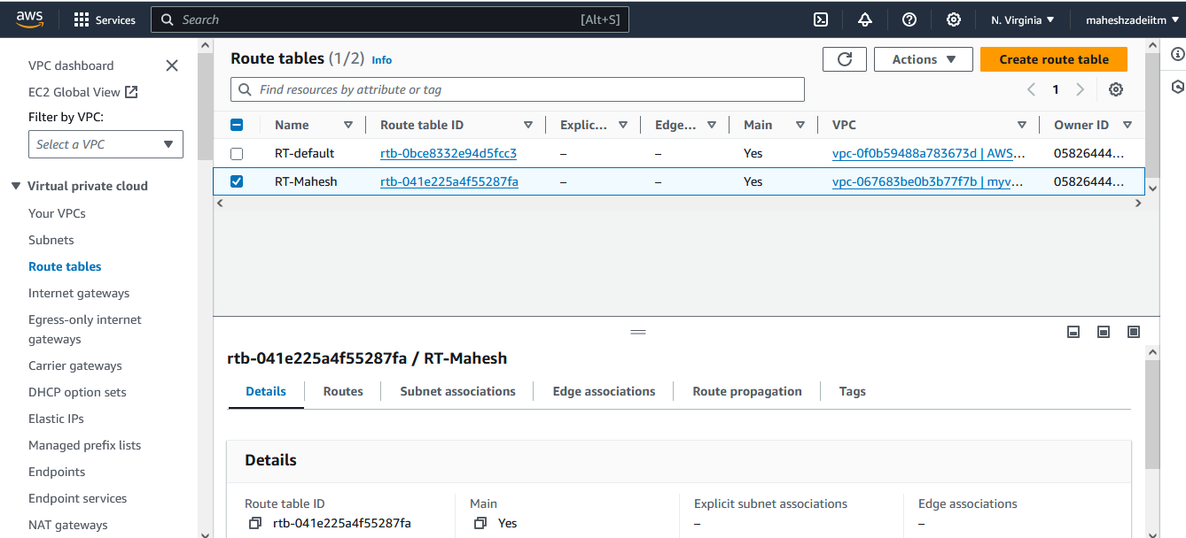

**Once the VPC Created nect jo is to create the subnet**

**Go to subnet**

**Click on create subnet**

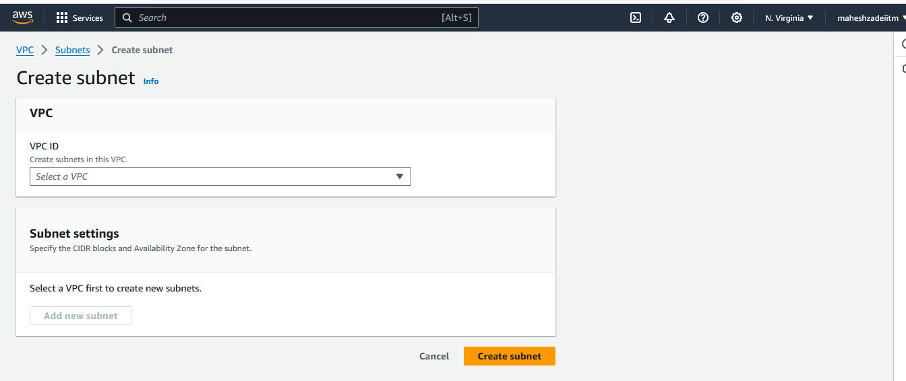

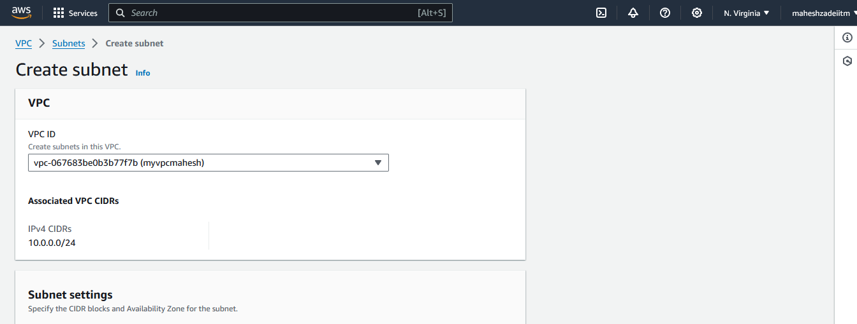

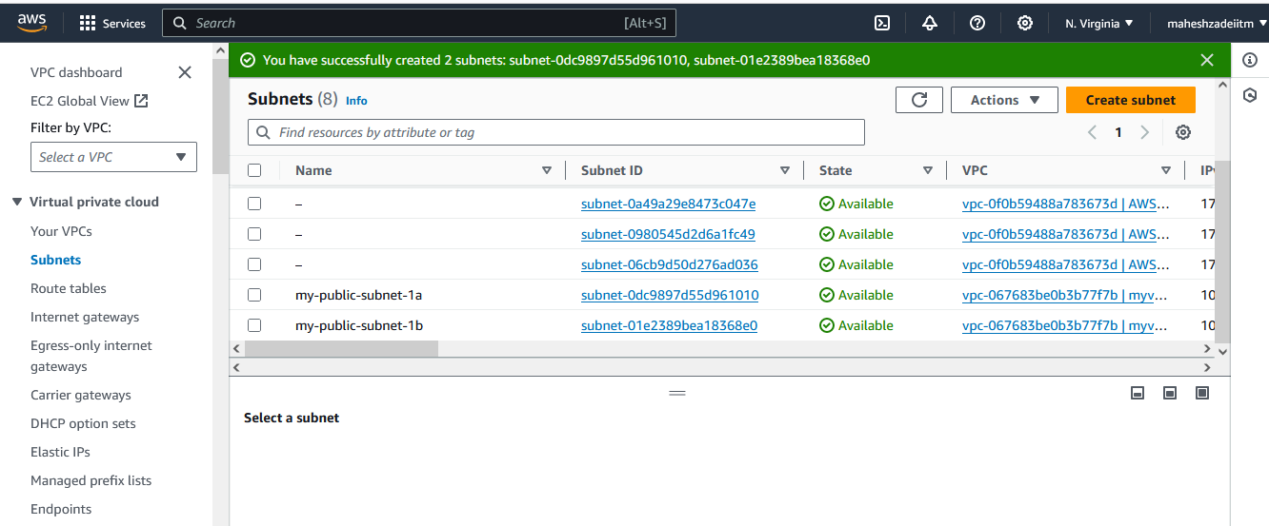

**Select VPC   
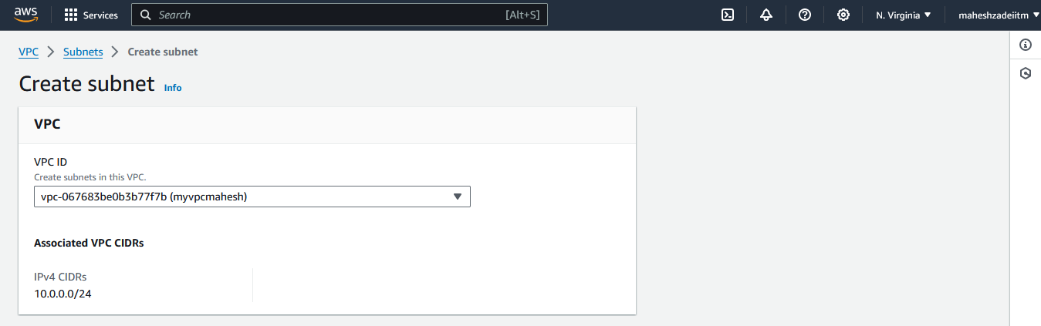**

**Crate 1 public and 1 private subnet**

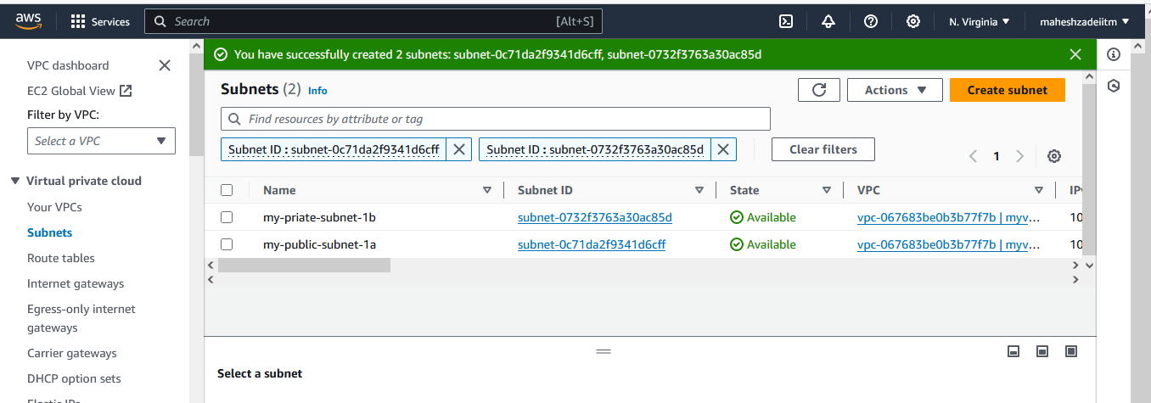

**Select the CIDR rage from Calculator**

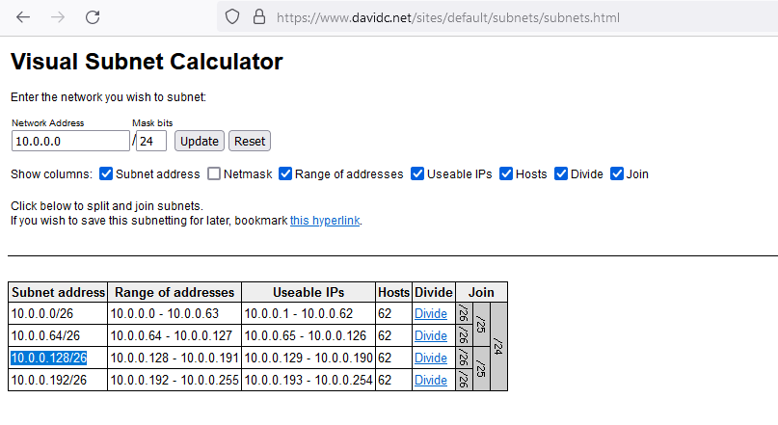

**Private subnet created**

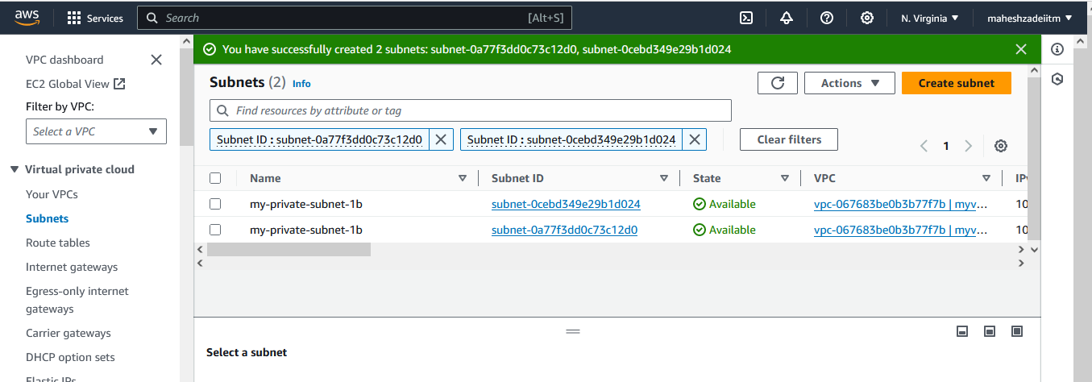

**Now go to Route Tableand make the RT public**

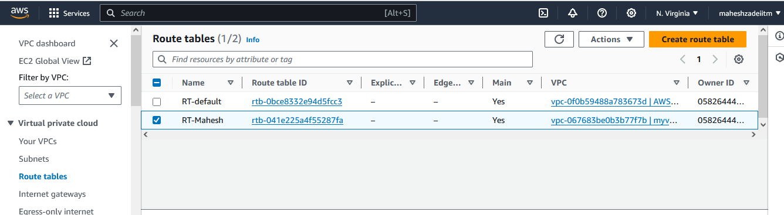

**Go to subnet association and save association**

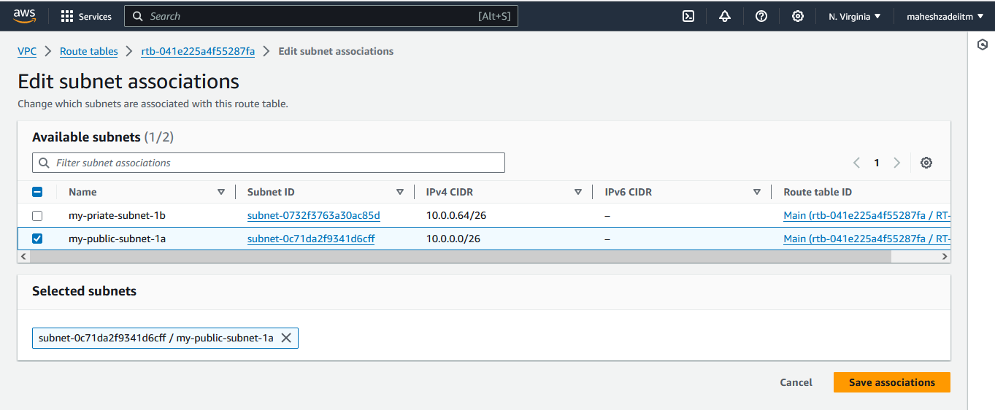

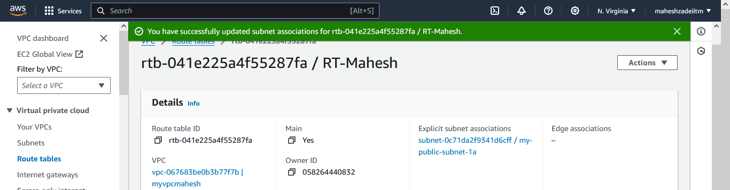

**Now create private RT**

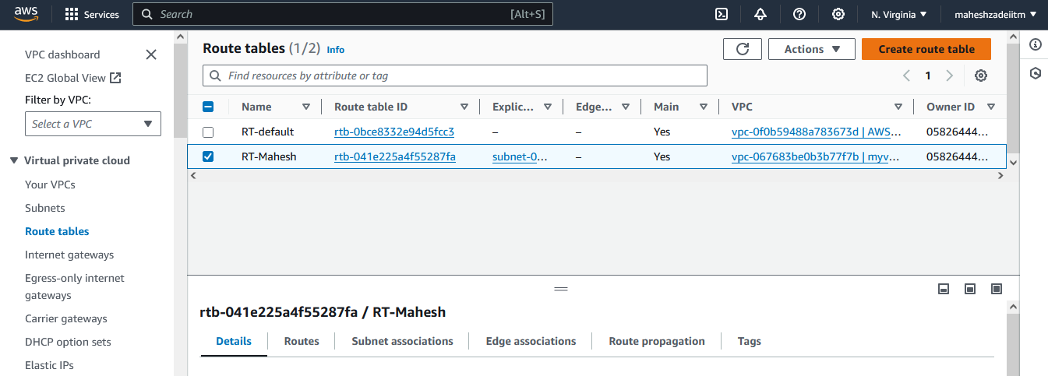

**My private RT created**

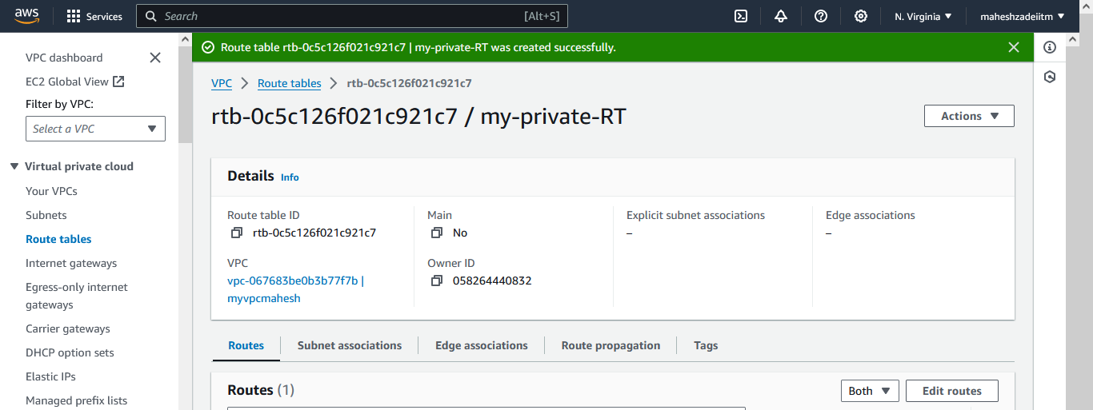

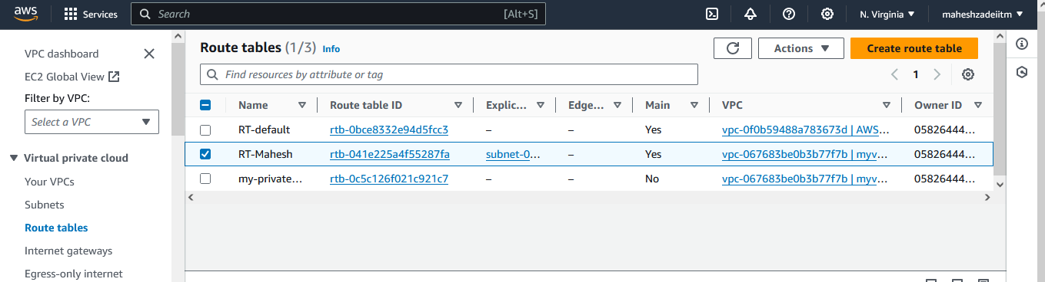

**Associate private subnet private RT and public subnet to public RT**

**Now go to create internet gateway**

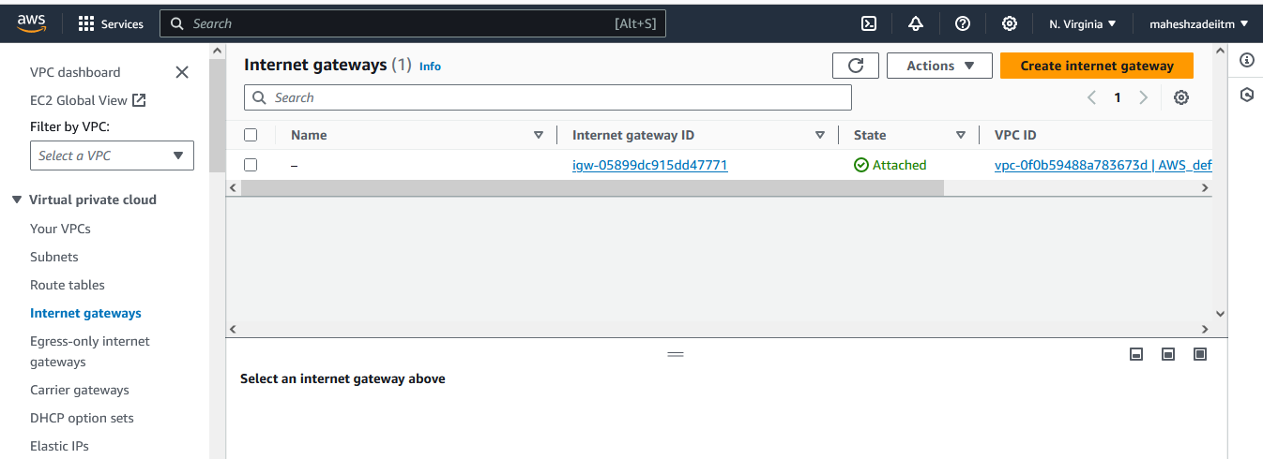

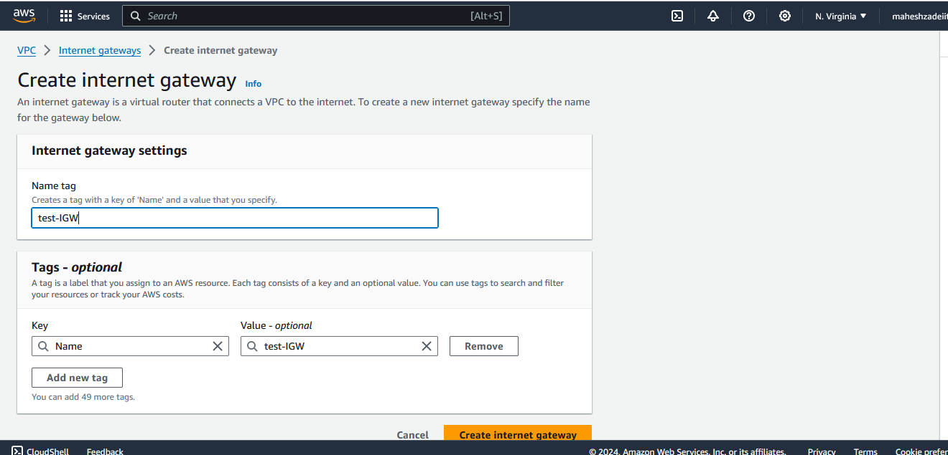

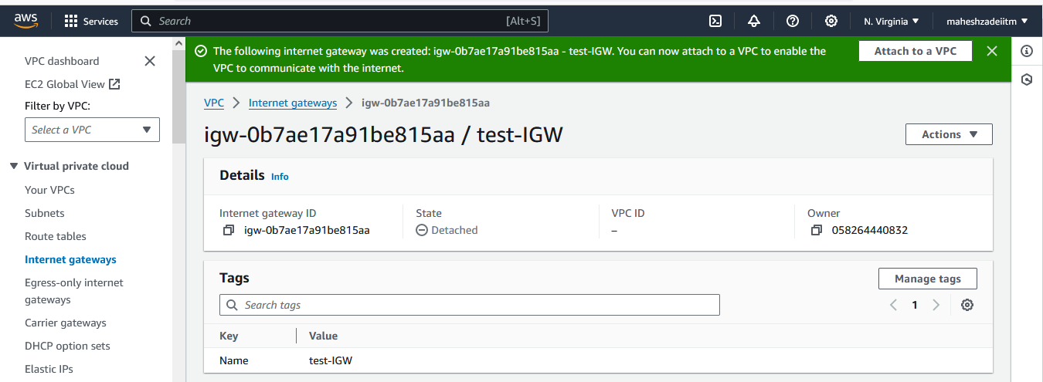

**IGW attach to VPC**

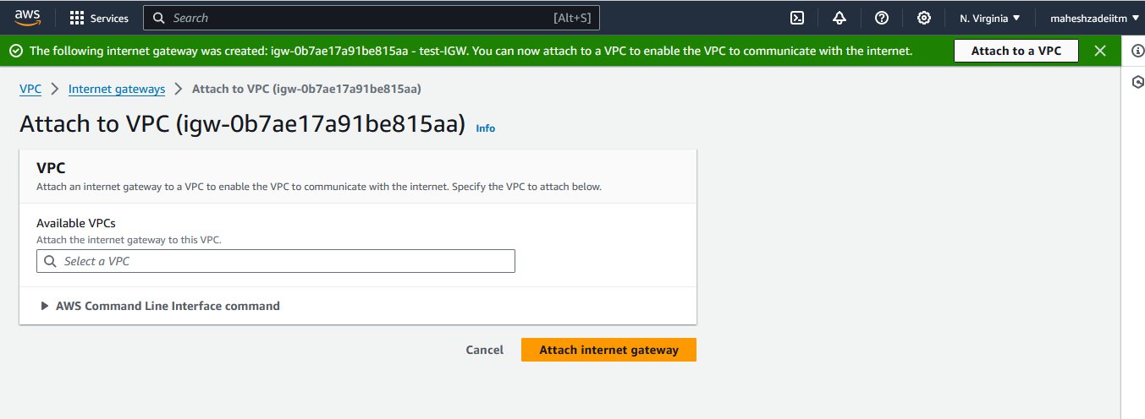

**Click on attach internet gateway**

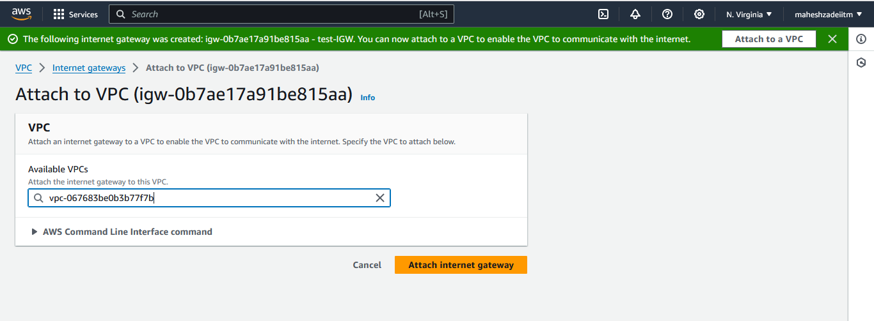

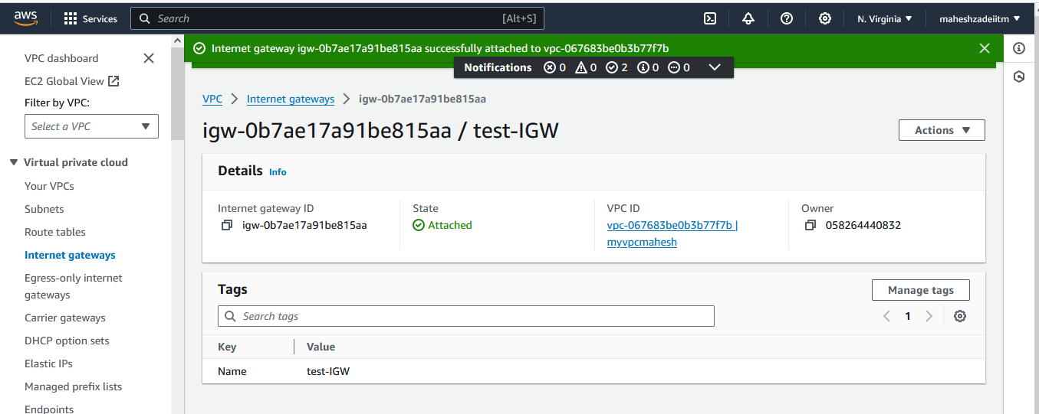

**Now go to Route table**

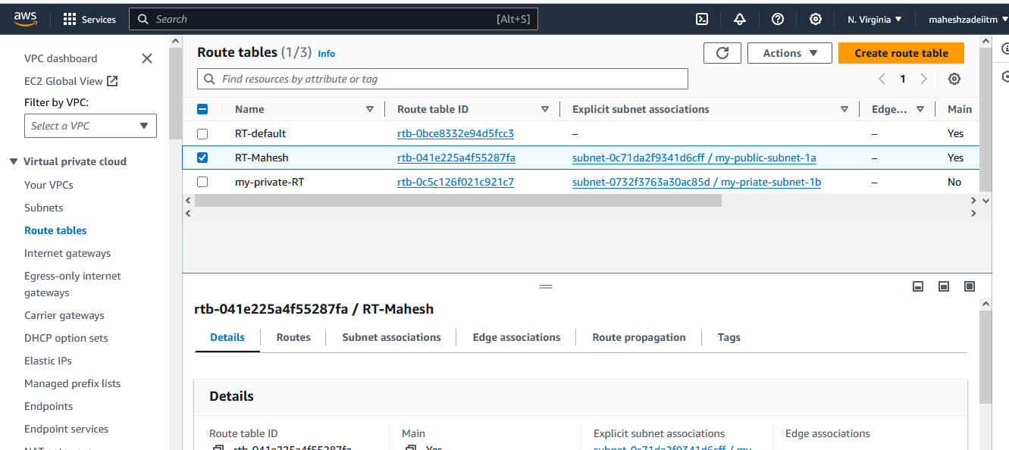

**Click on edit route**

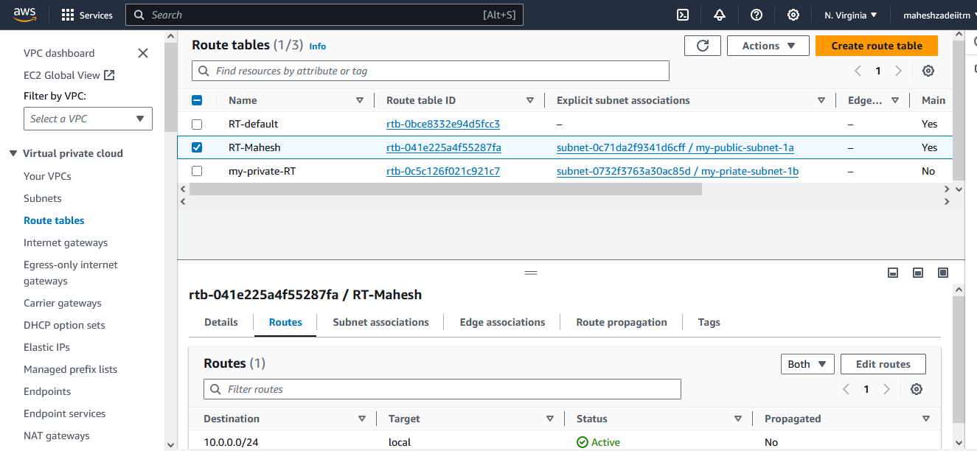

**Select add route and internet gateway**

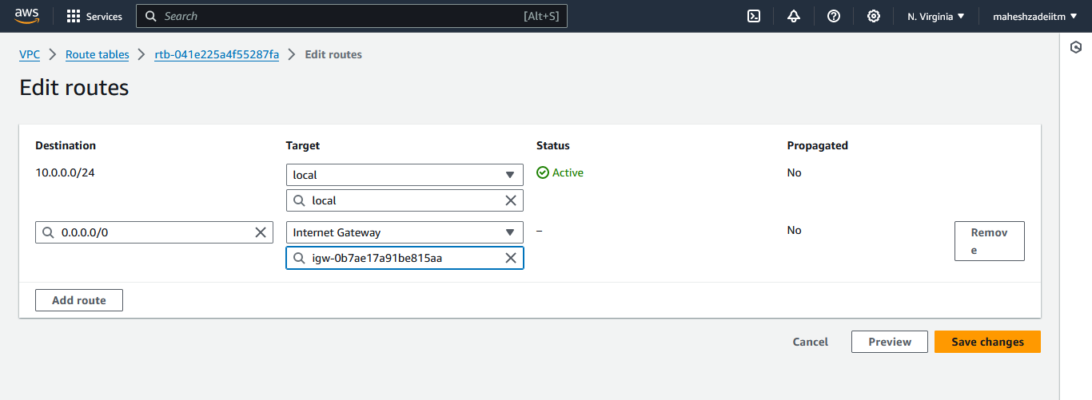

**And save changes**

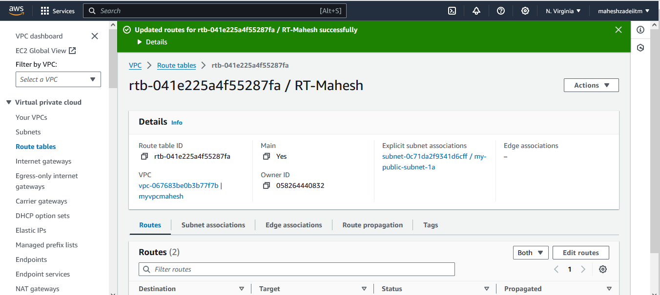

**Why we create the private subnet .**

**If we want access the database in that subnet we can access the database via NAT Gateway**

**So now create the Nat Gate gateway**

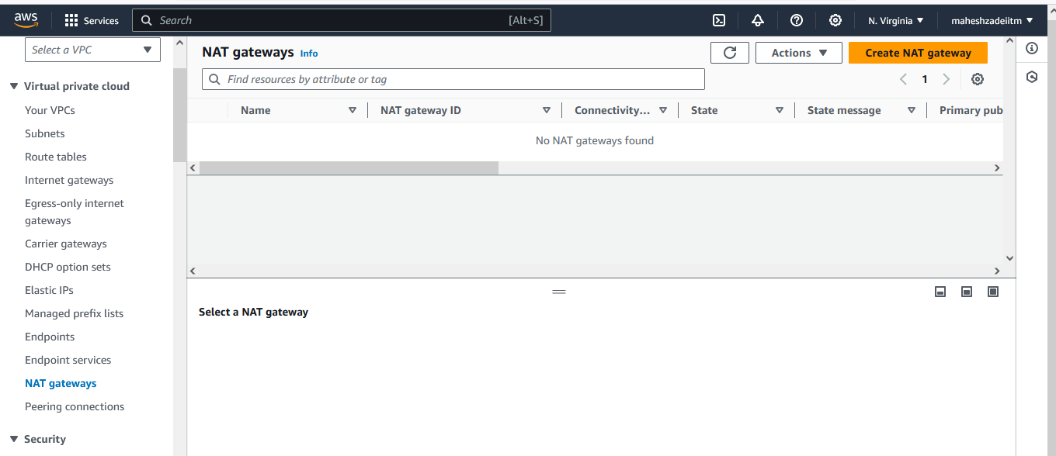

**Create NAT Gateway in public subnet**

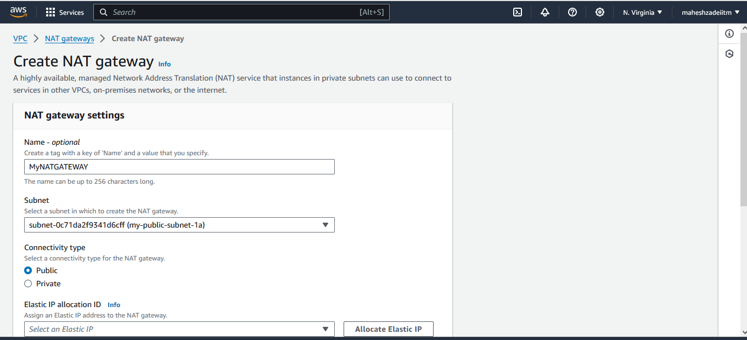

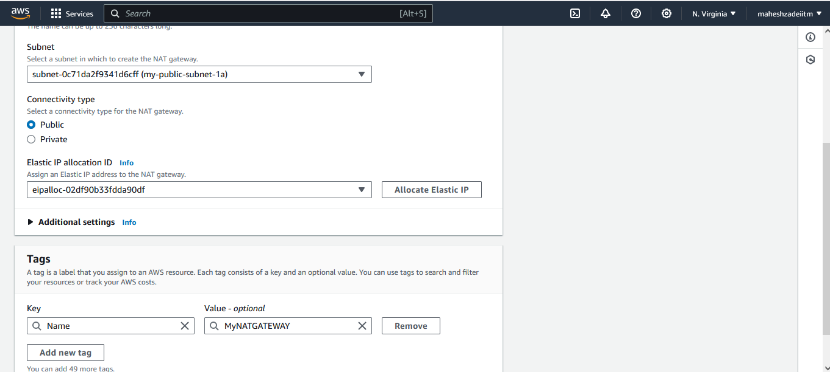

**Click on NAT Gatewqay**

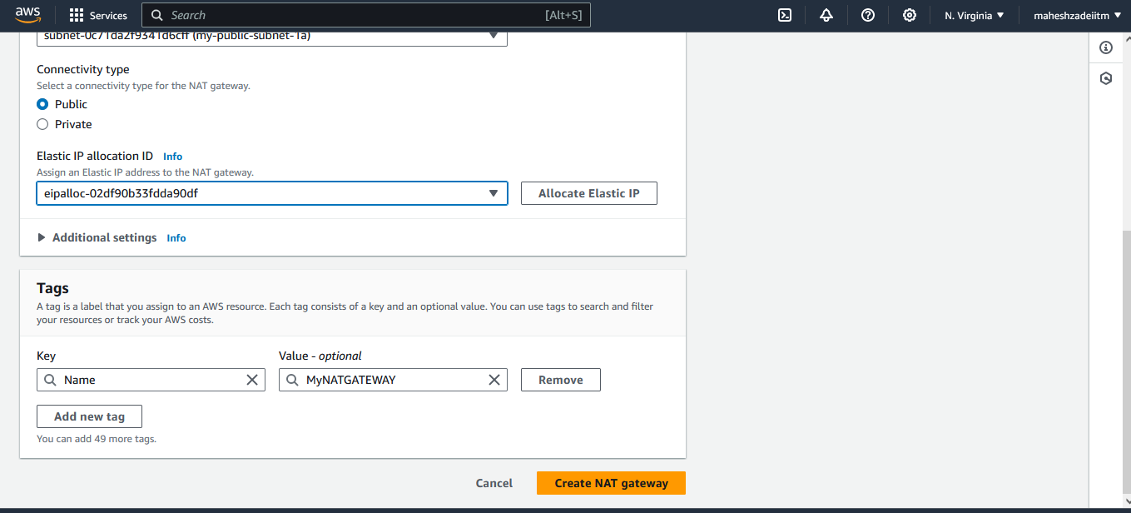

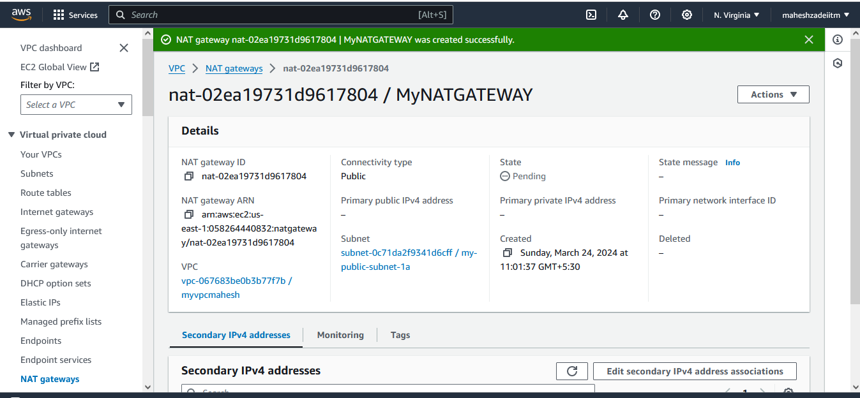

**NATGATEWAY Created**

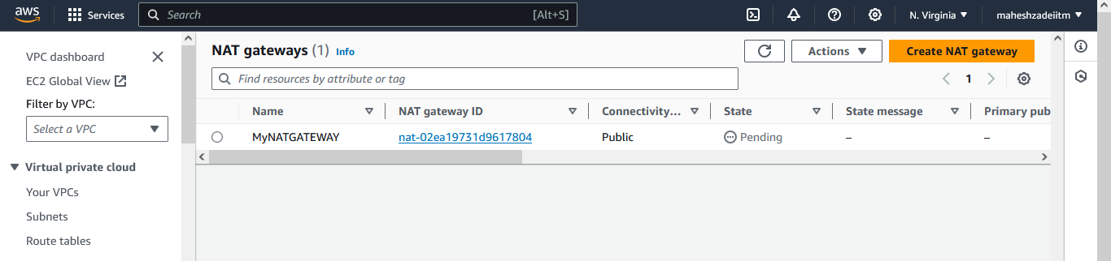

**Wait till available**

**Now NAT gateway os available**

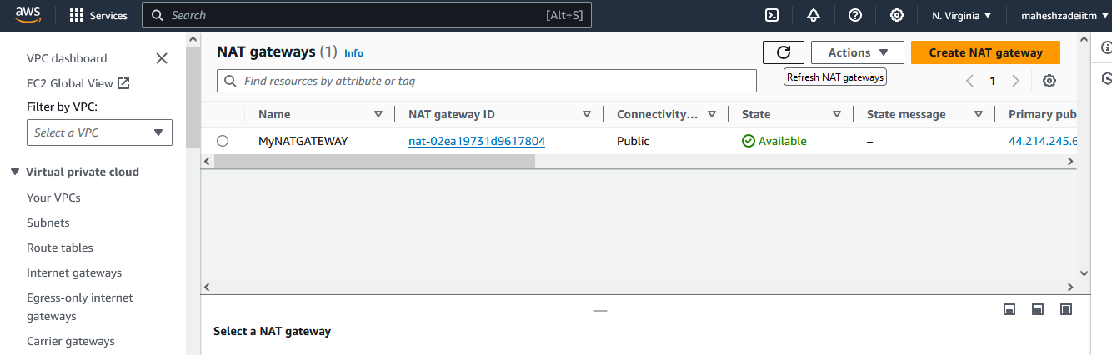

**Now go to private Route Table**

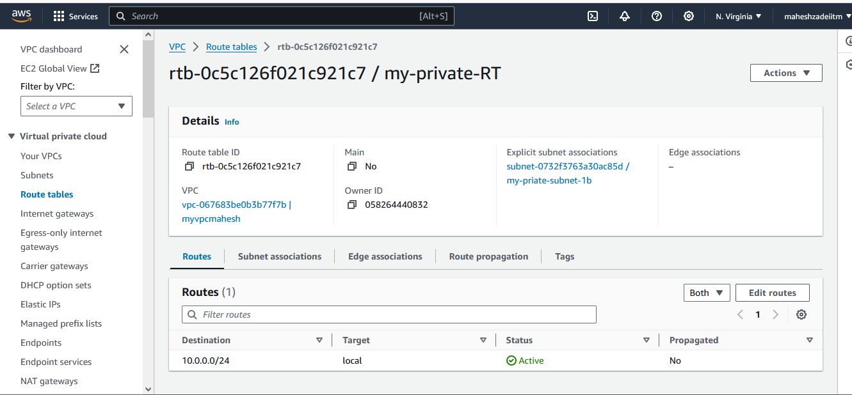

**Edit Route Table**

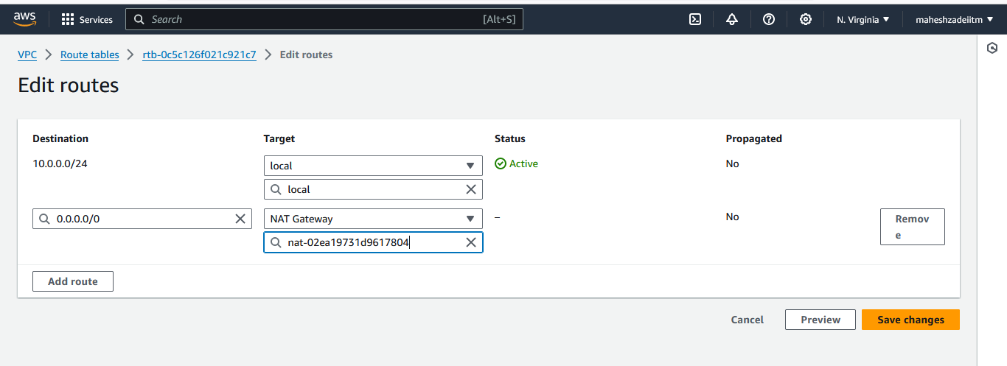

**And Save Changes**

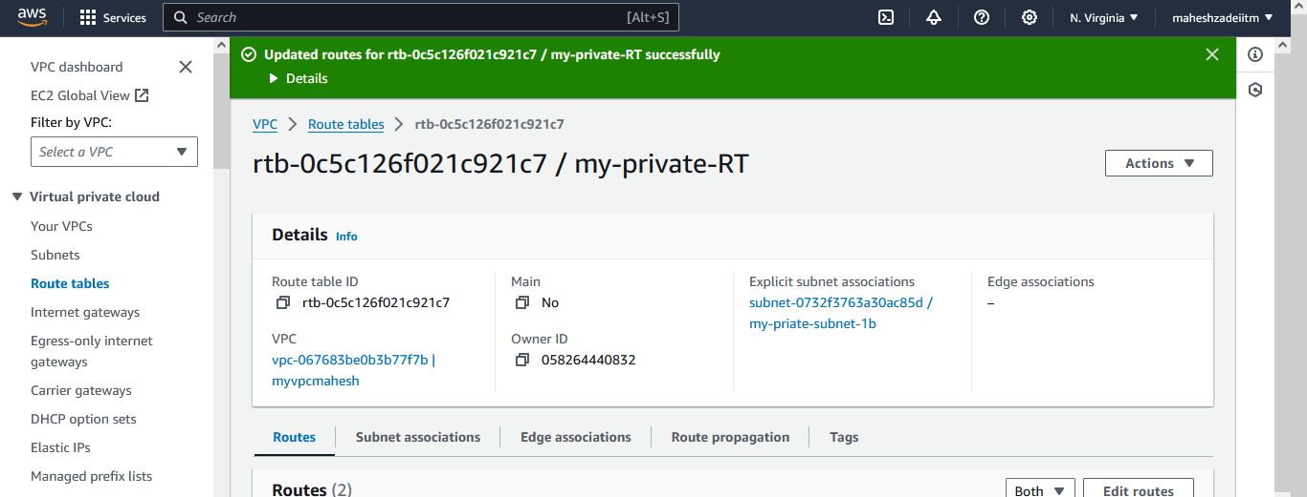

**Now Go to EC 2 and launch EC 2 Windows Machine**

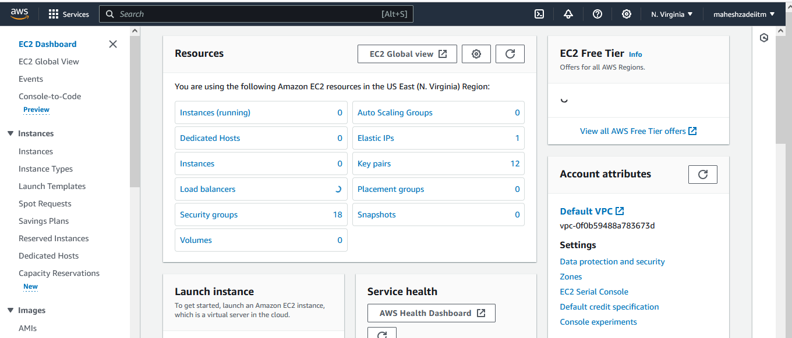

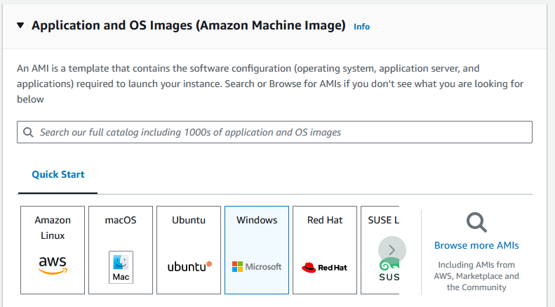

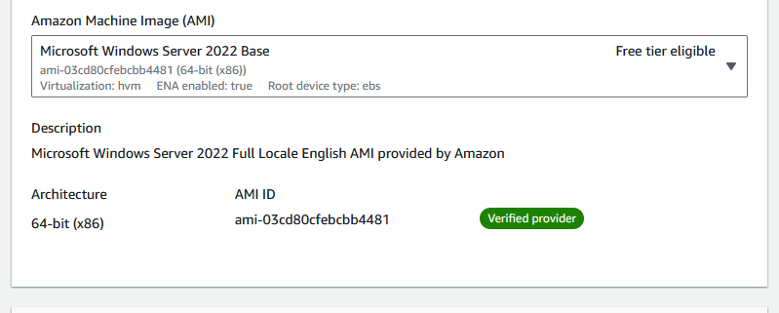

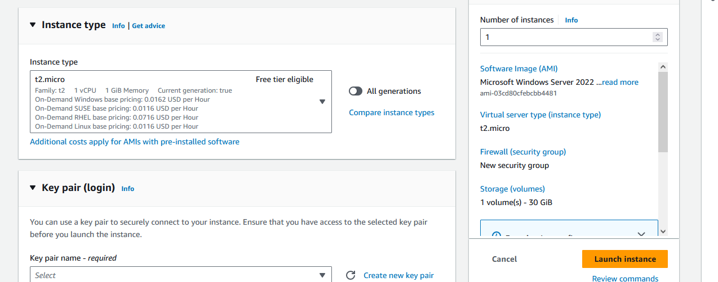

**Download Keypair in N Virginia**

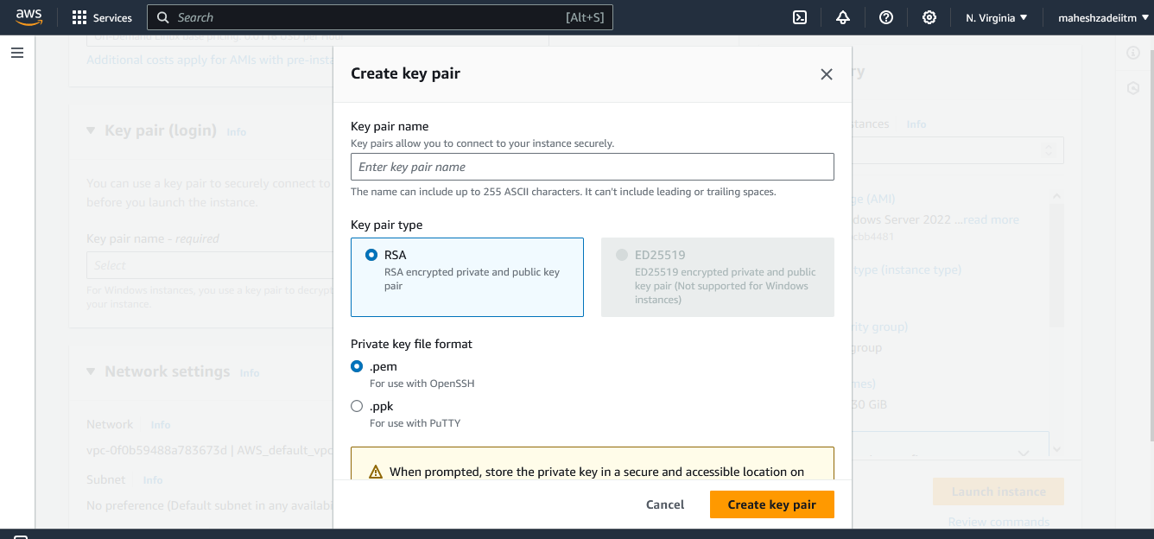

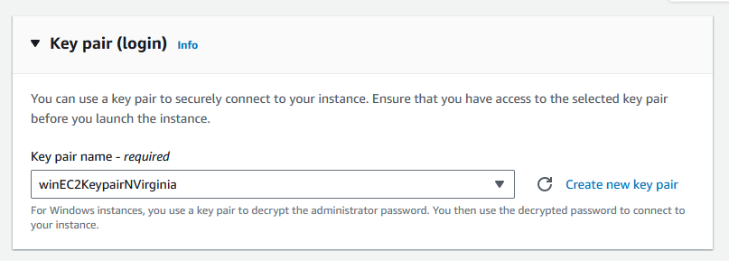

**Edite network setting**

**Select my VPC / public Subnet and Click on auto assigned public IP**

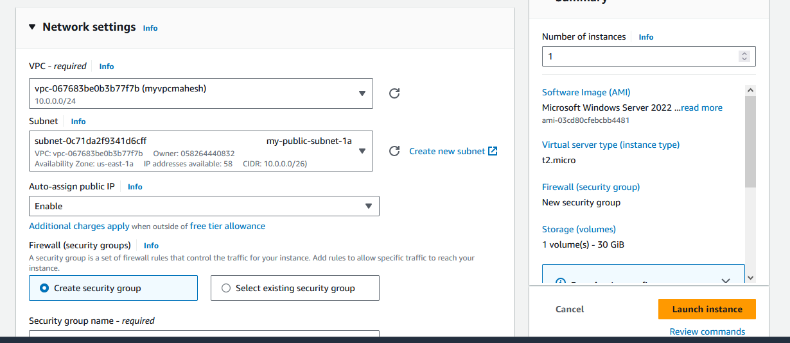

**Security group can be default**



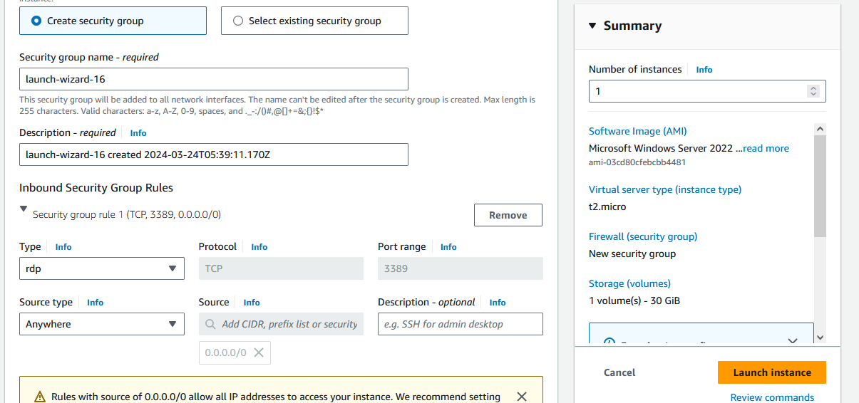

**Keep the setting as it is and launch instance**

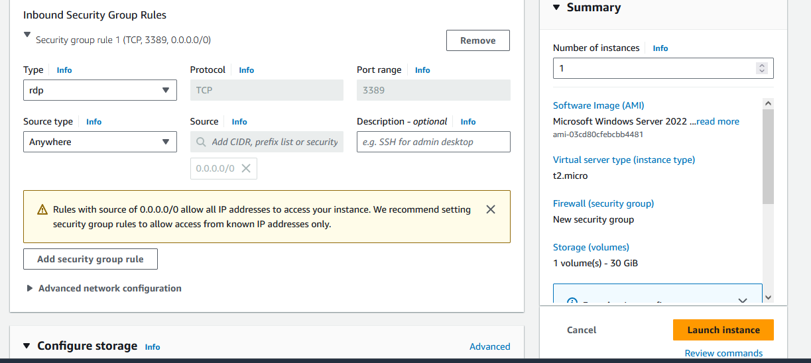

**Storage 30 GB**

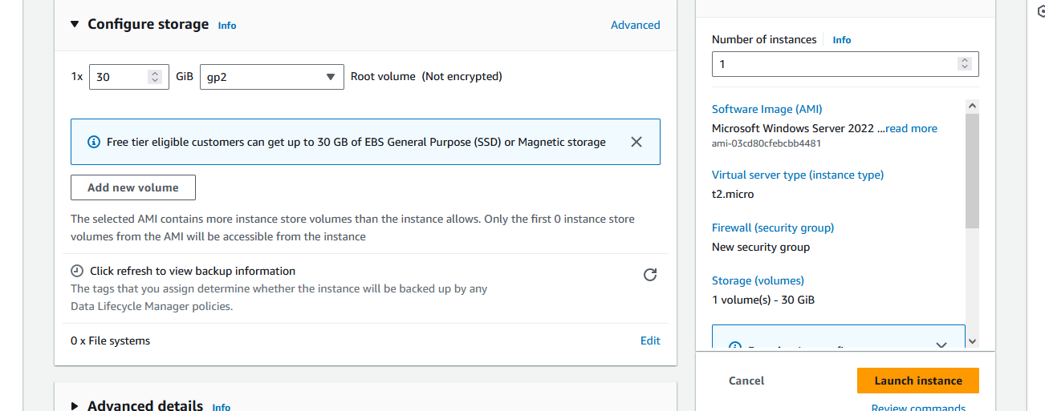

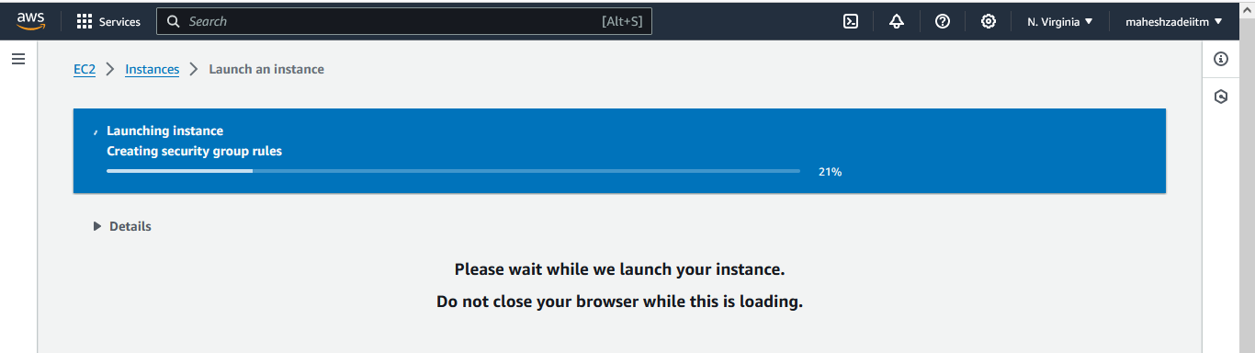

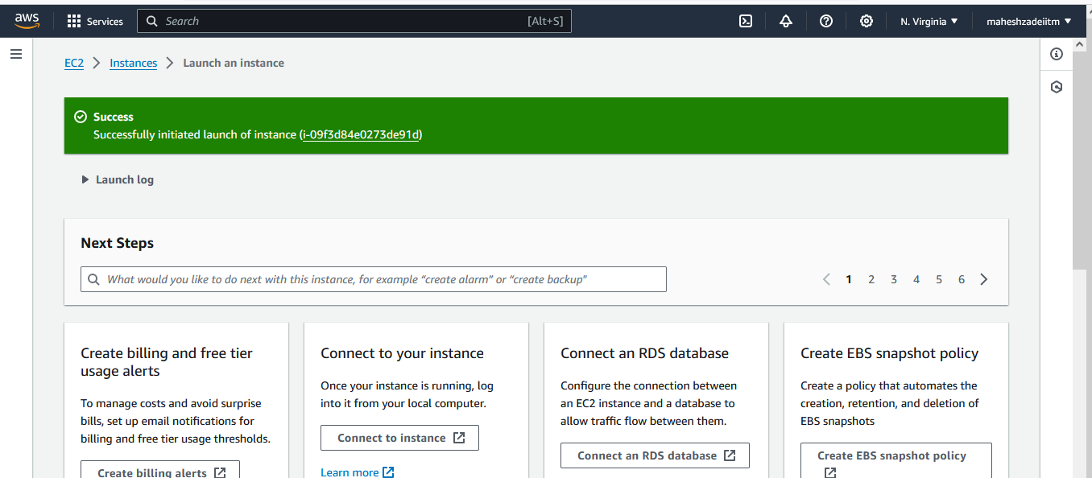

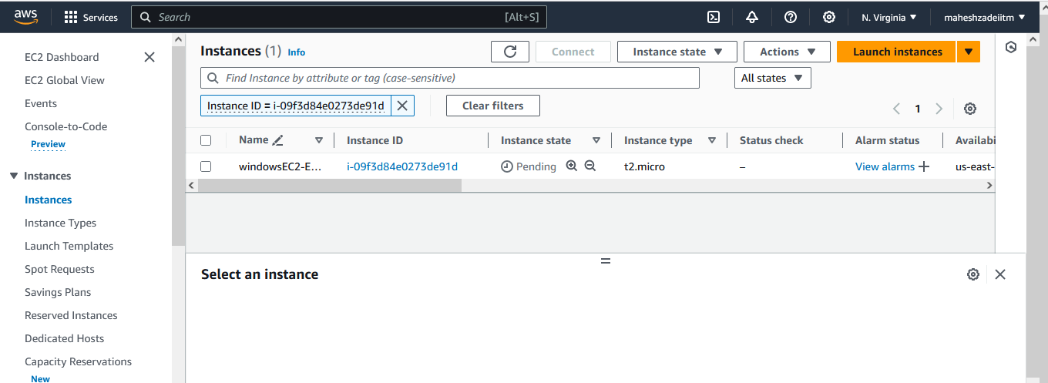

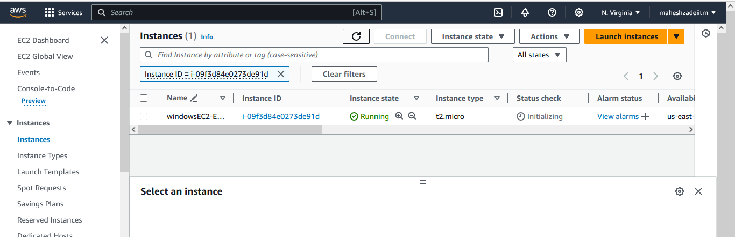

**Go to action and click on connect**

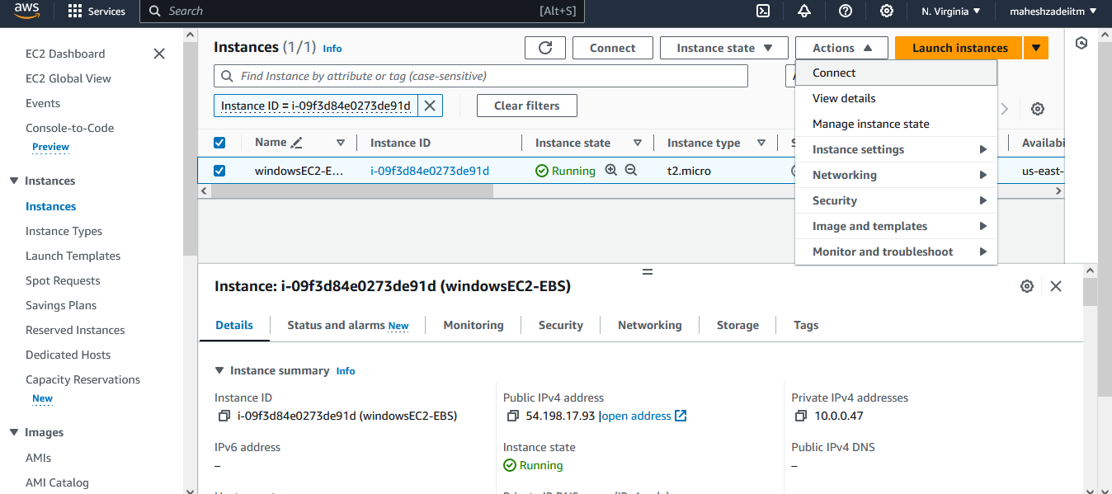

**Click on RDP Client**

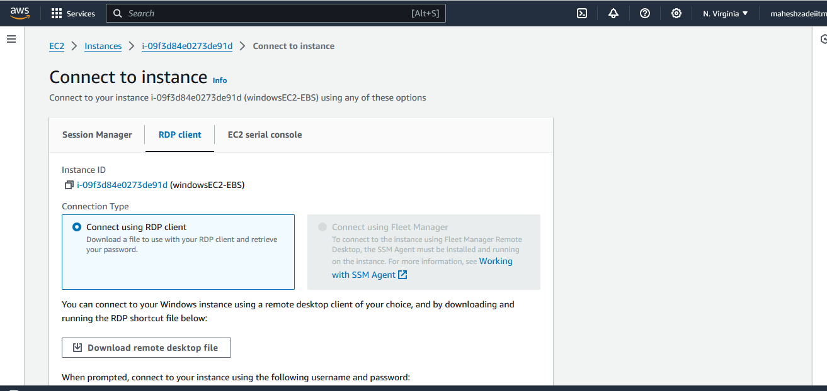

**Download remoate desktop file**

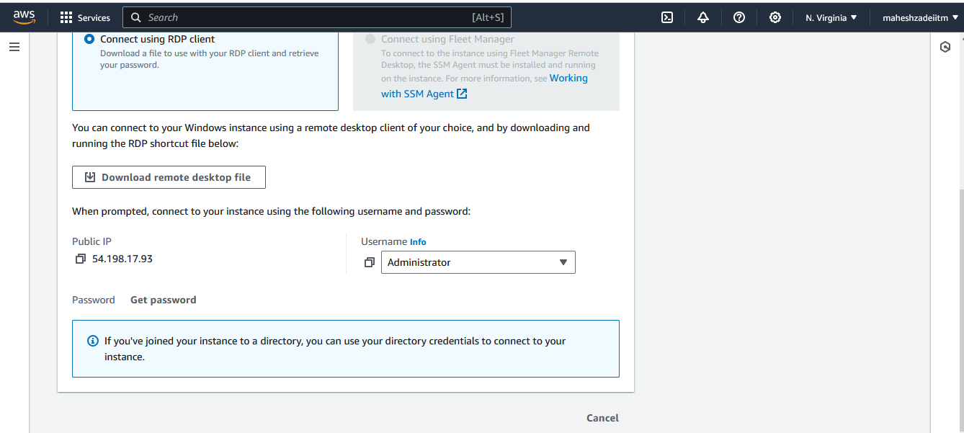

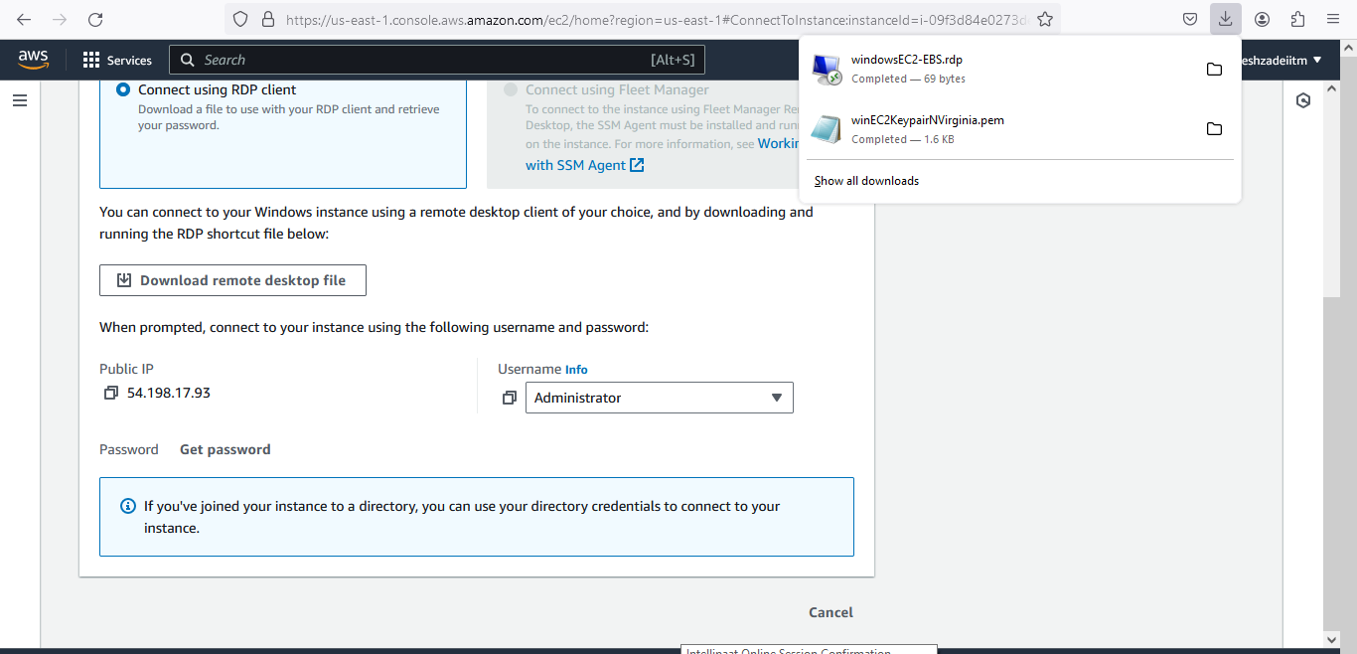

**Click on gate password**

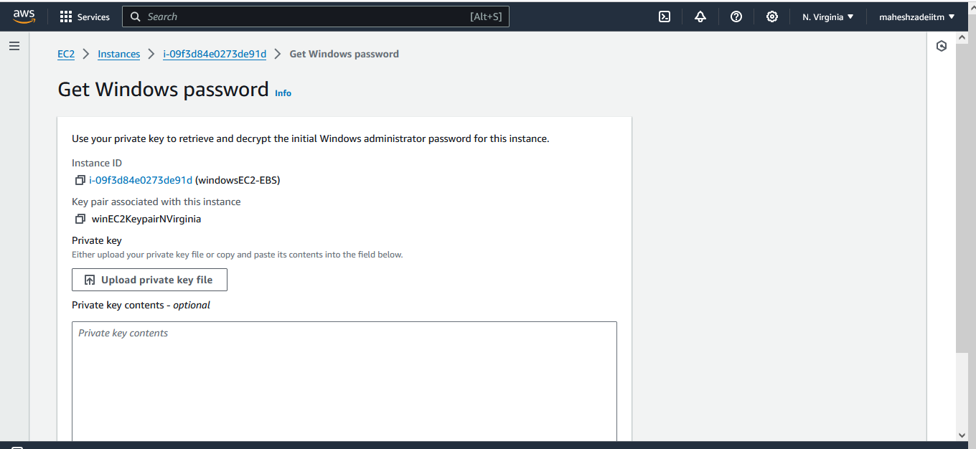

**Upload private key**

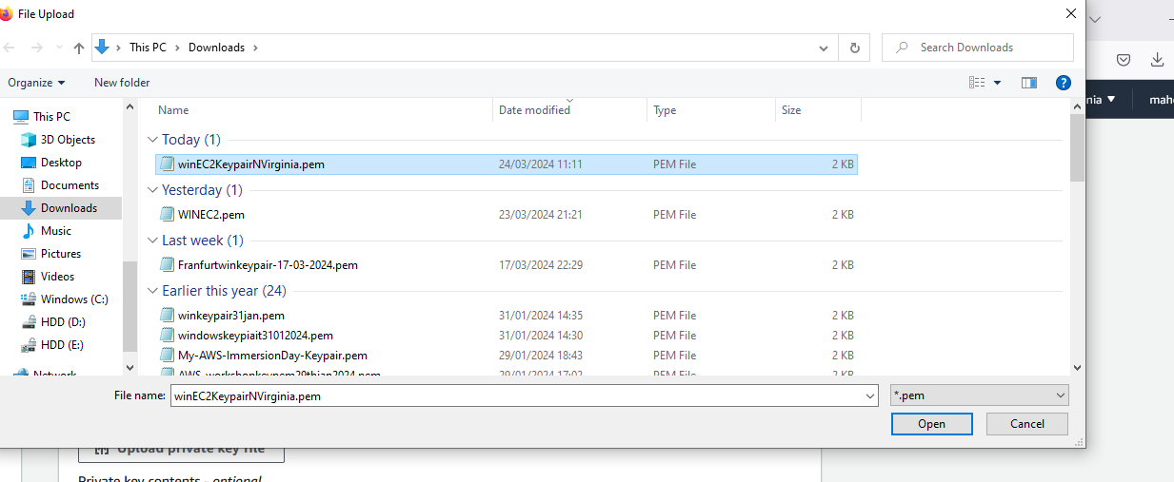

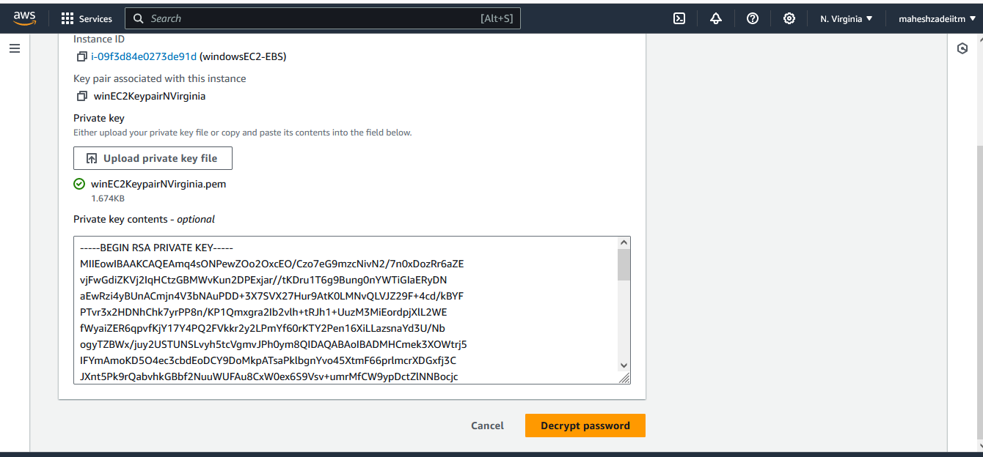

**Click on decript password**



**Copy password and user name**

**Username :** Administrator

**Password :** Wdzav)Bv2slh.WR8)n?HZhce*68c477t

Click on Remote desktop file which is download

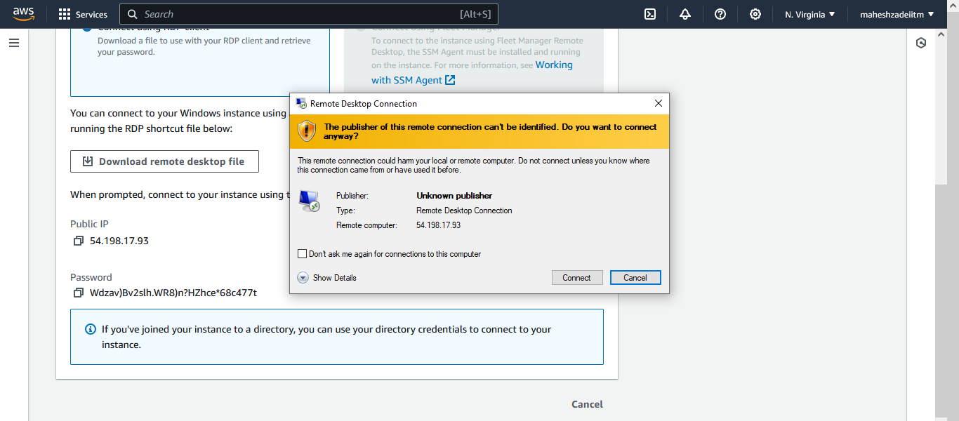

**And click on connect**

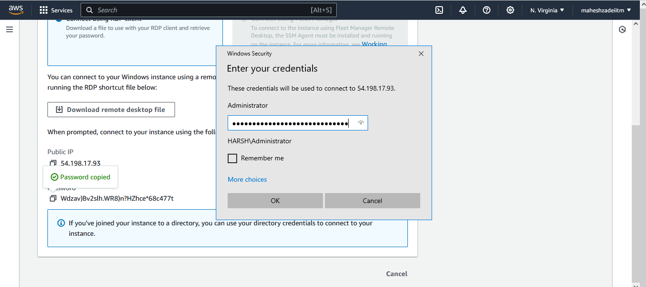

**Copy password**

**And click on ok**

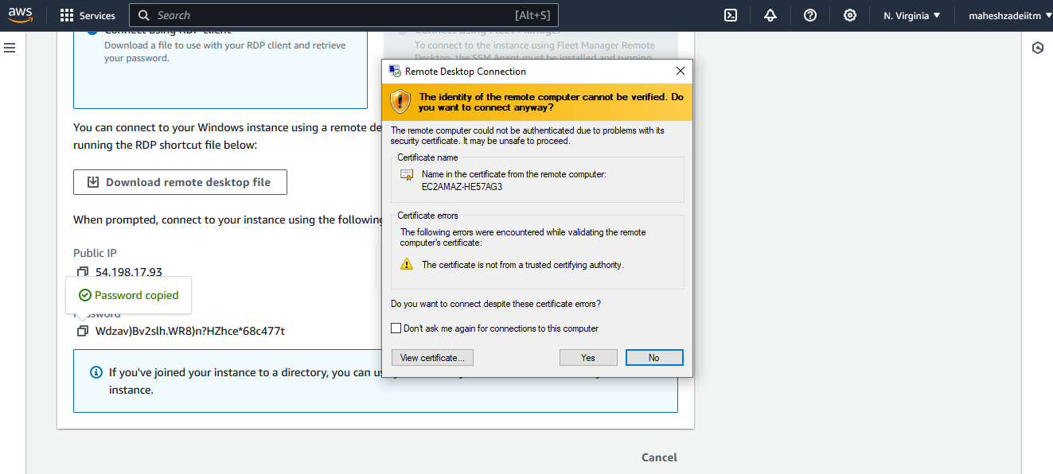

**Connected to Windows EC2 insatnce**

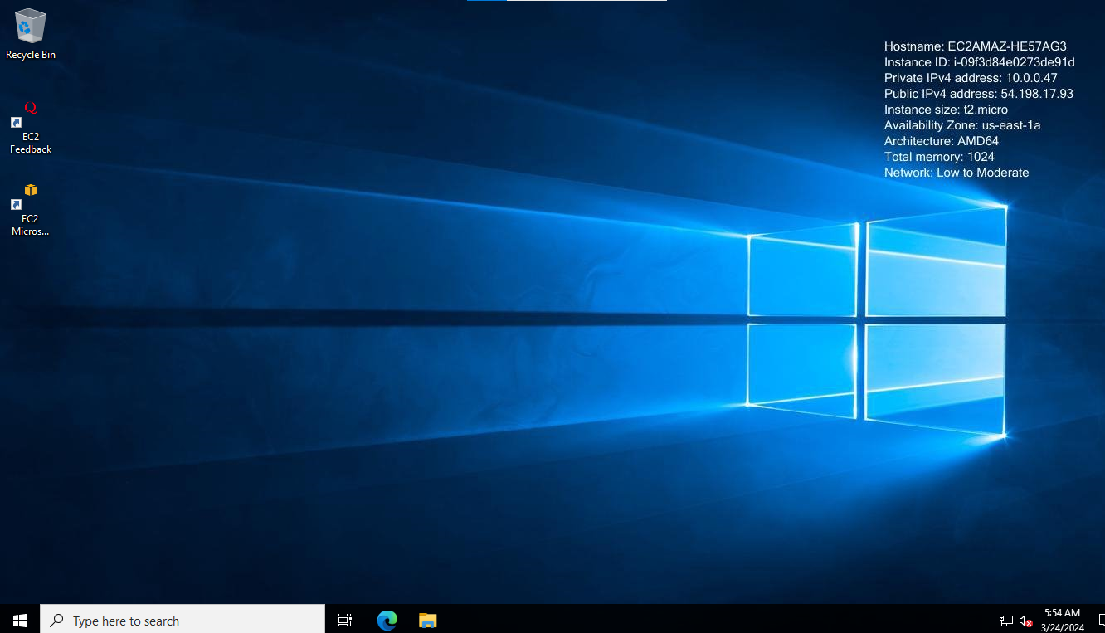

**Now Change the default password of administrator**

**Now go to computer management**

**Go to user and groups and then click on users**

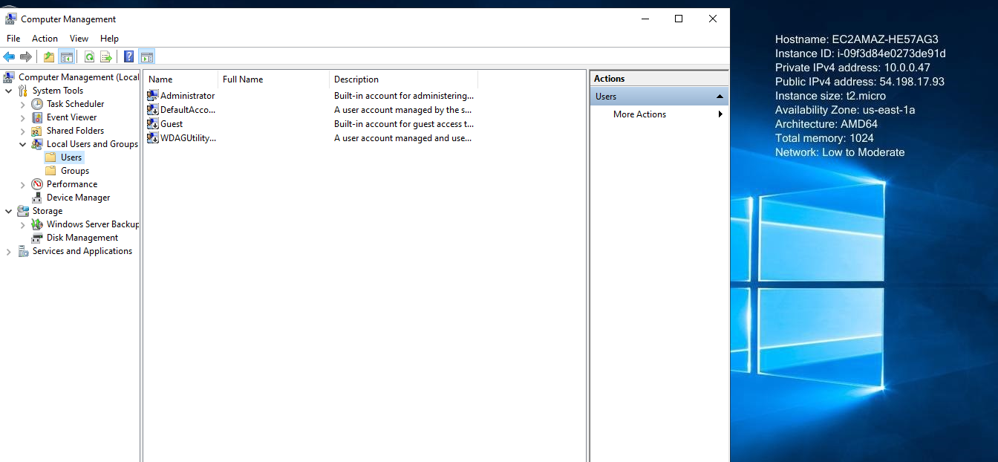

**Right clik on administrator**

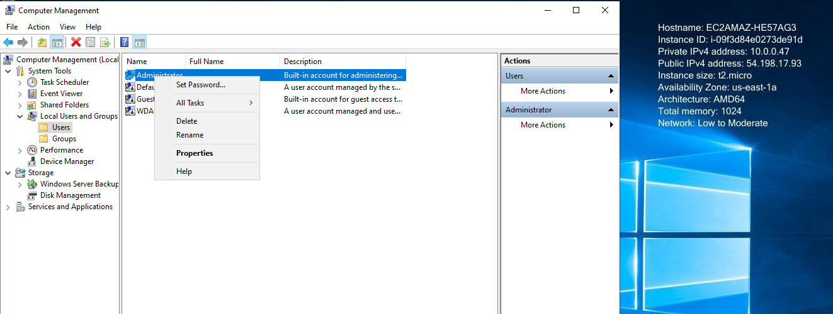

**Click on set password**

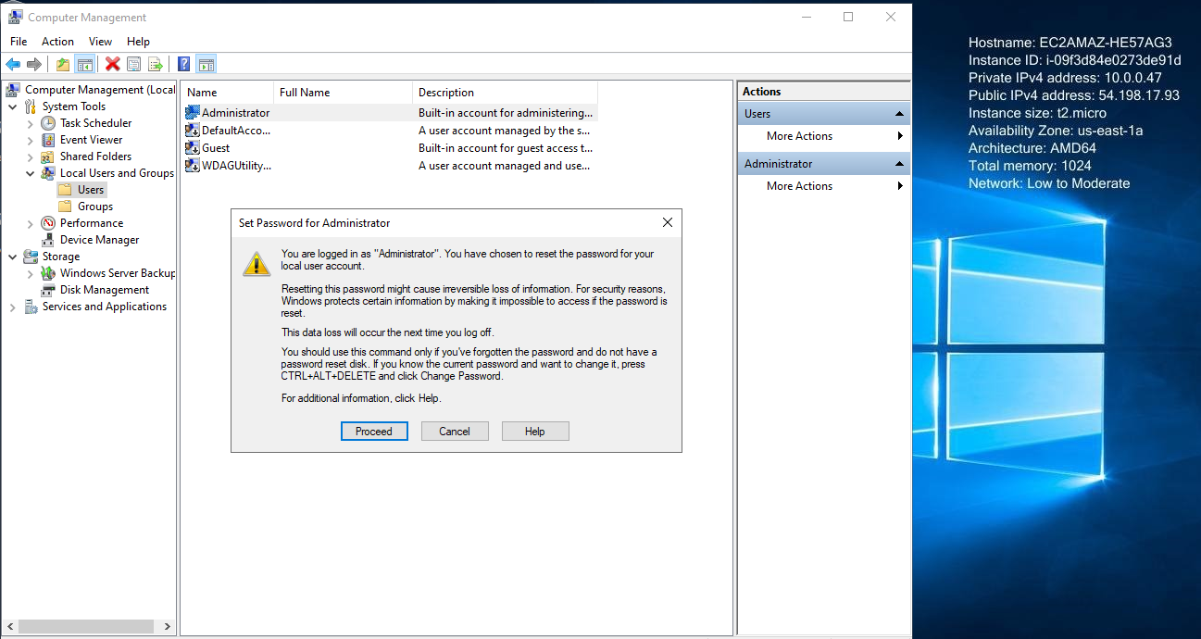

**Proceeed**

**Enetr New and reneter password**

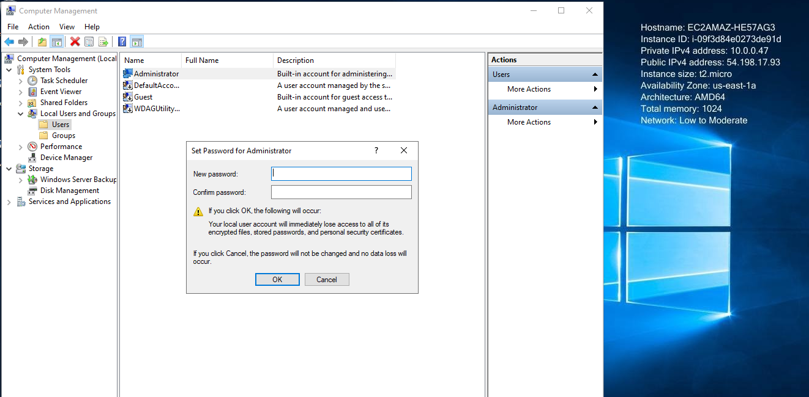

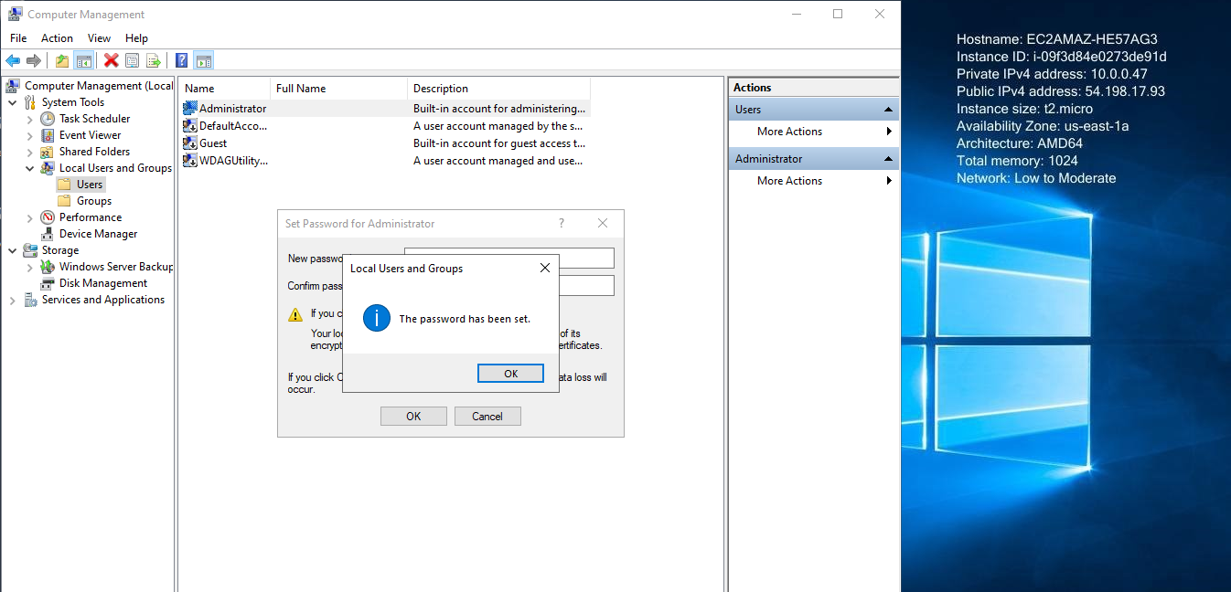

**India@1234 is a password**

**And then click on ok**



**Now again try to connect with new password**

**Go to AWS Console**

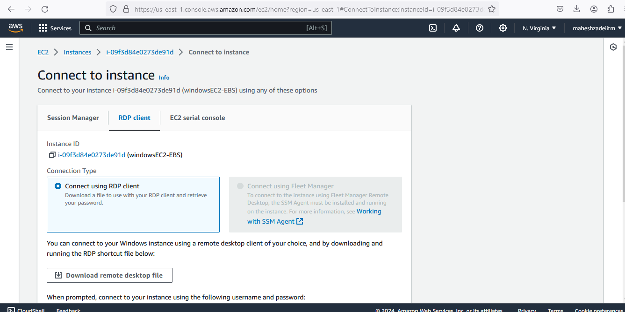

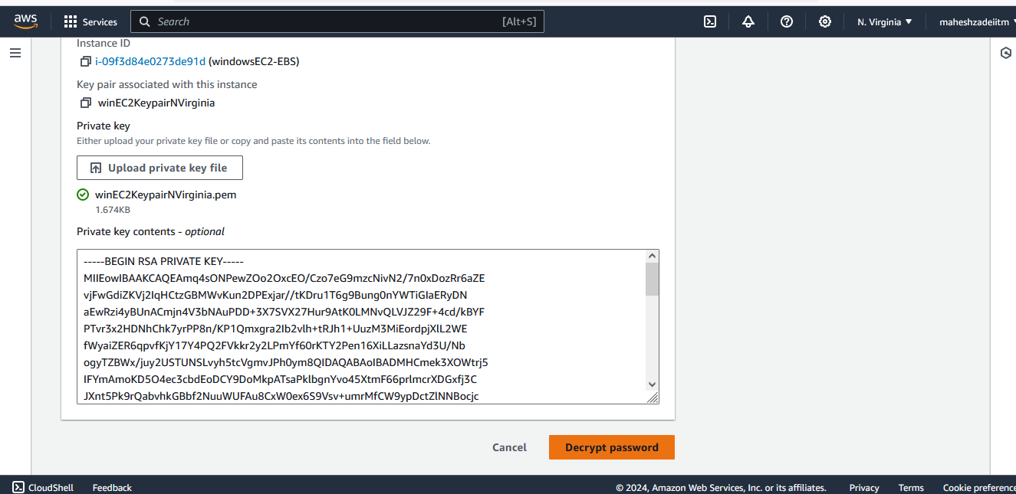

**Decrip password again**

**Copy the password and paste in**

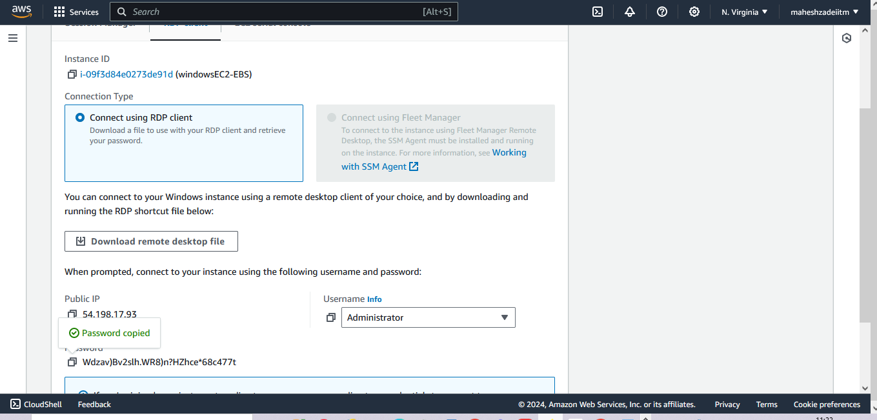

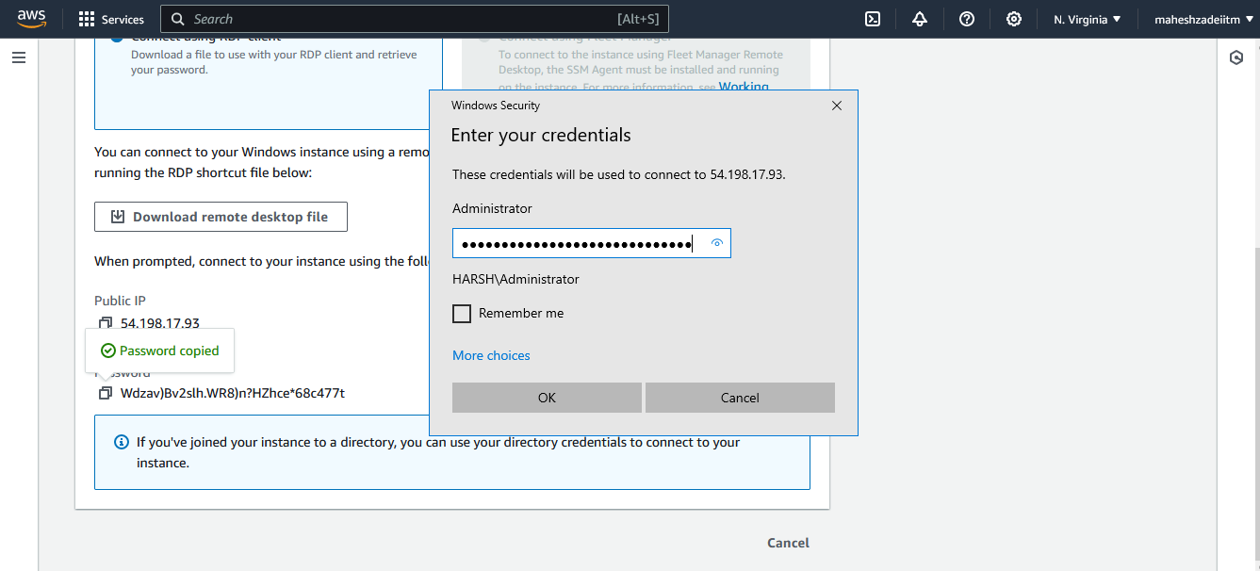

**Not connecting after changing the password**

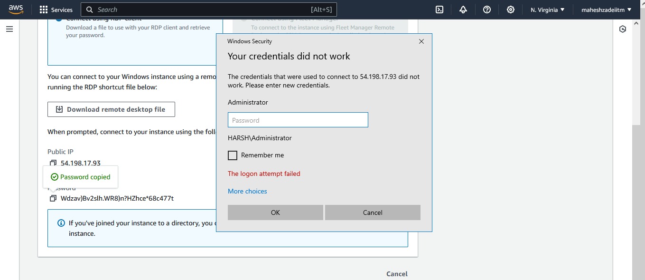

**Put the password India@1234 which is changed**

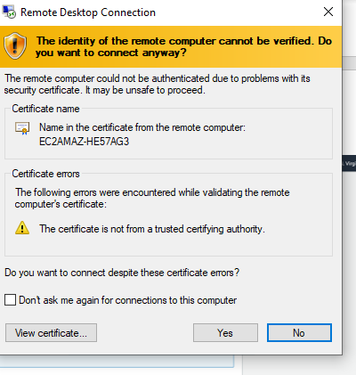

**Connect ing**

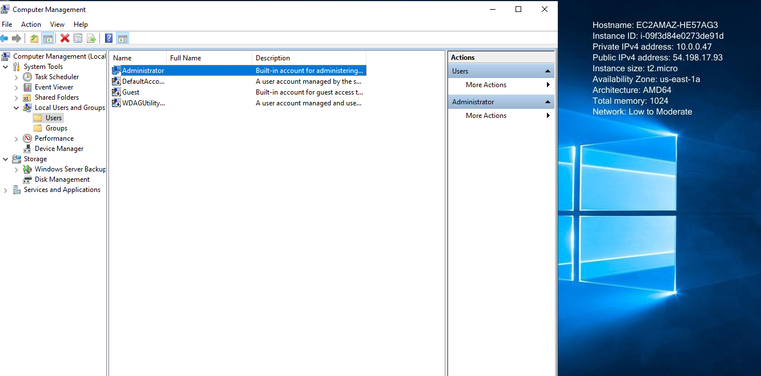

**Connected**

**Now Create the new user for login ( As multiple use will log in the account )**

**Go to computer Management**

**Then user and Right to create the new user on Right Side and fill the information**

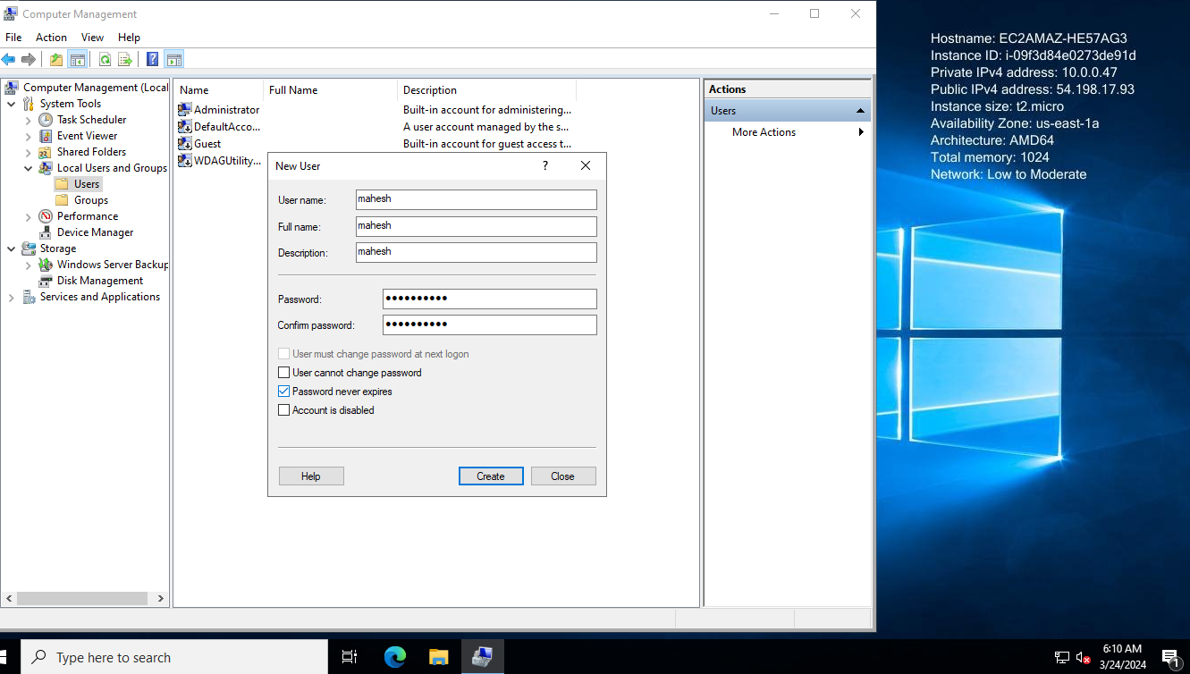

**Now go to groups and give the permission to user mahesh**

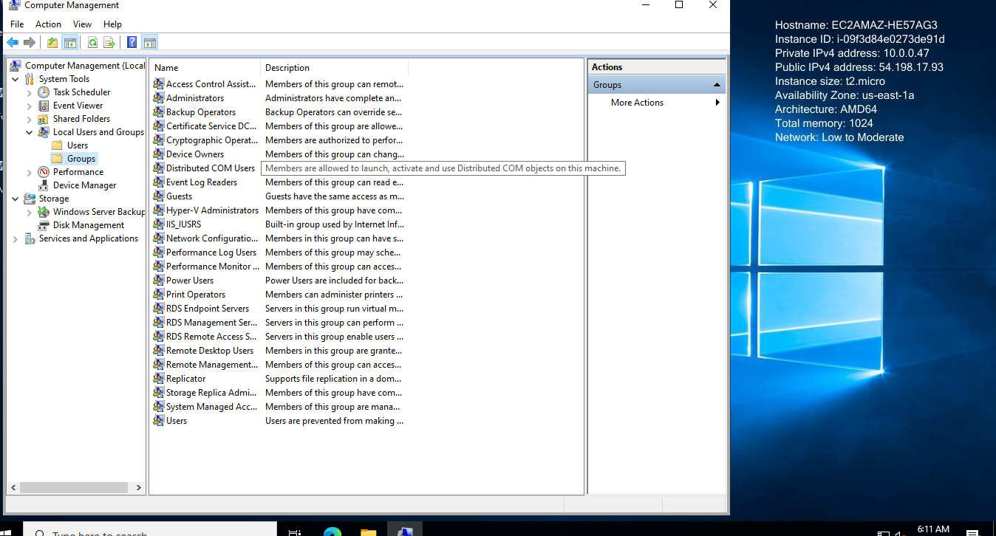

**Select administrator group and Right Click**

**Then click on add**

**Select user**

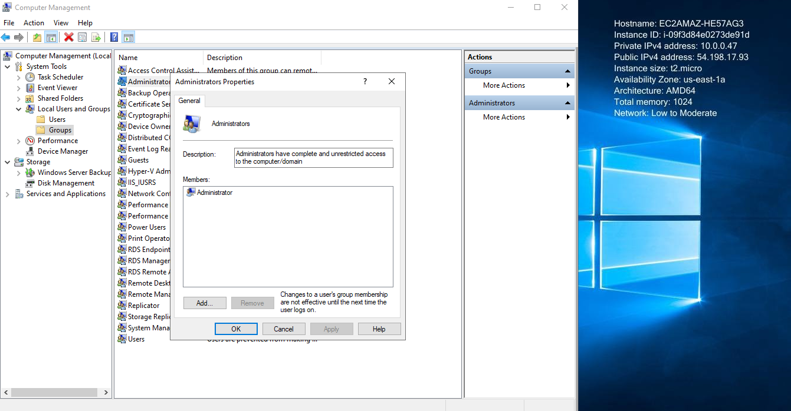

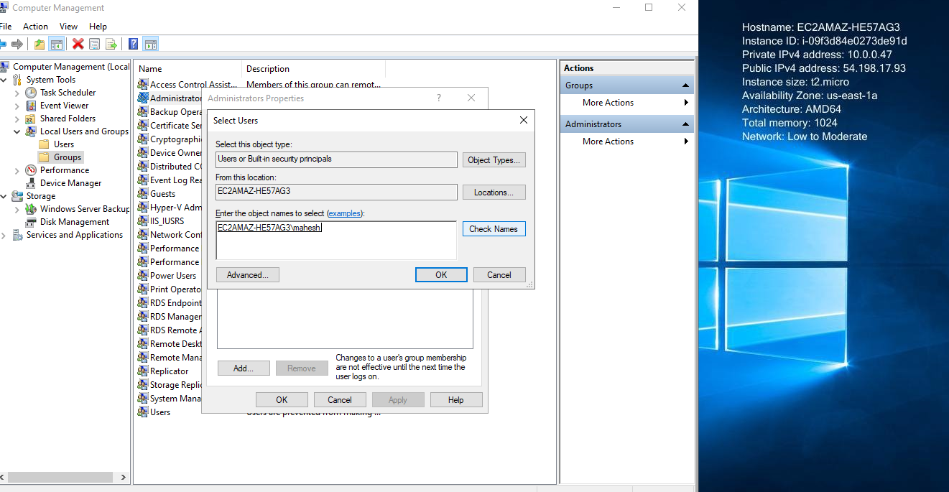

**Now login by user mahesh as well**

**By remote desktop**

**Type the command in run as mstsc**

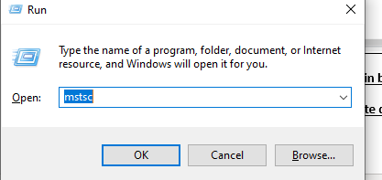

**And put the public IP**

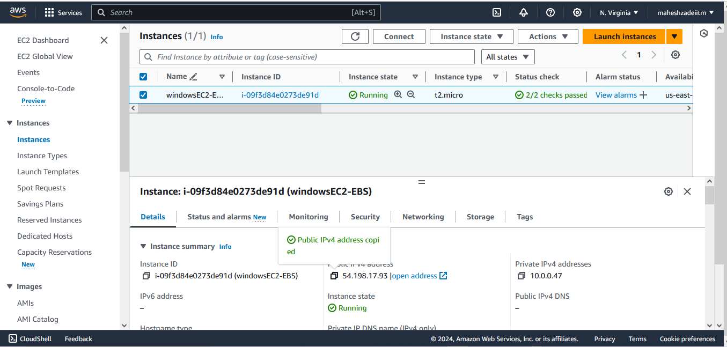

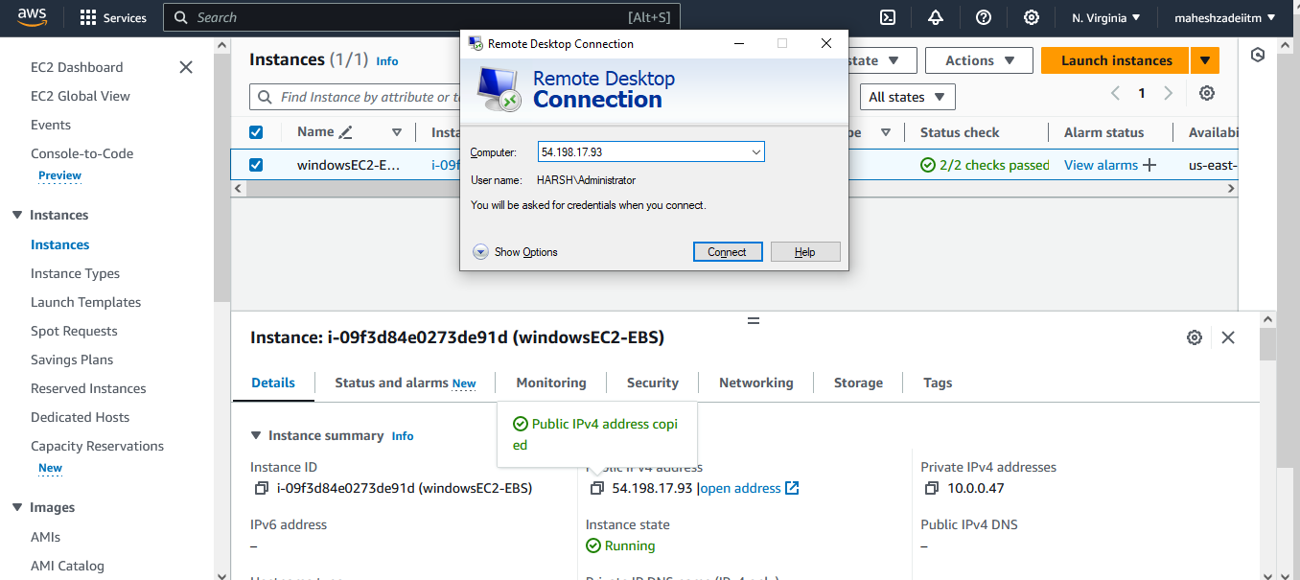

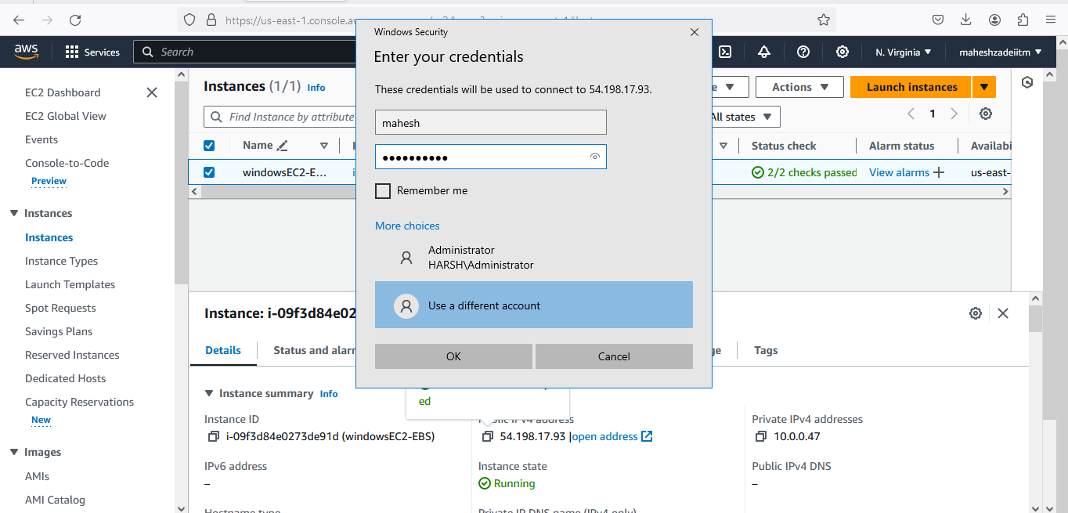

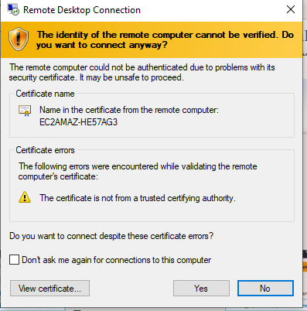

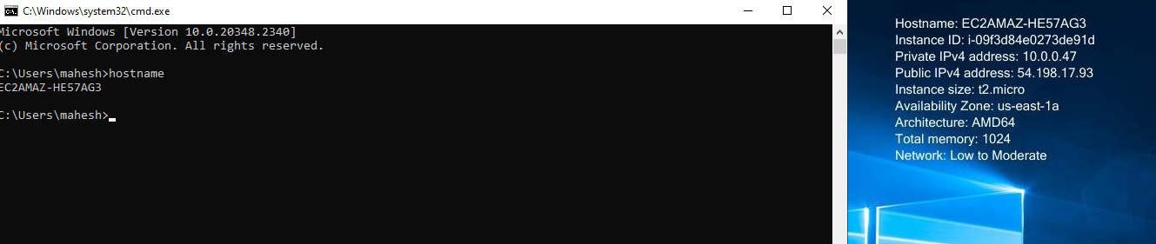

**And now for administrator user**

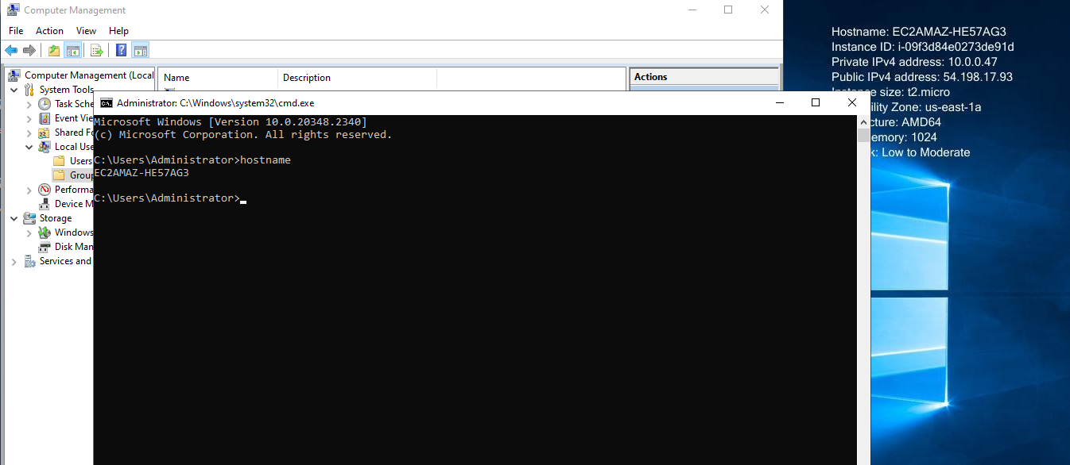

**Now Password change for administrator done**

**New user create tion done**

**Now I want to attach the volume to the EC2 instance**

**Now go to Volume of the EC2 instacne in AWS Console**

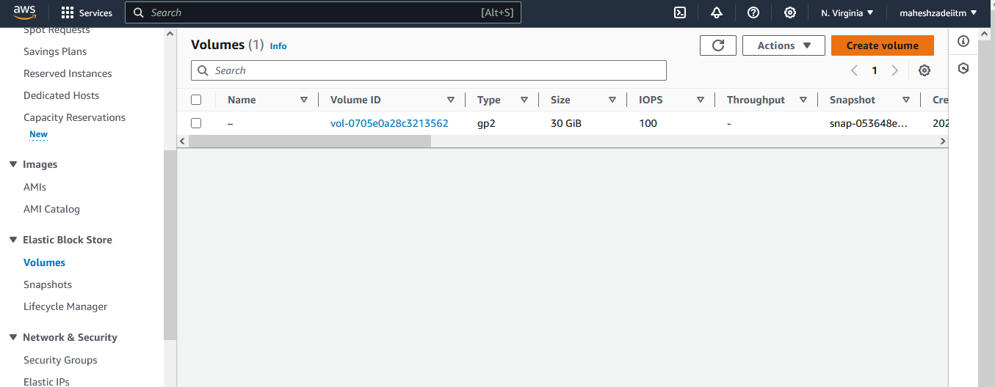

**Now click on create Volume**

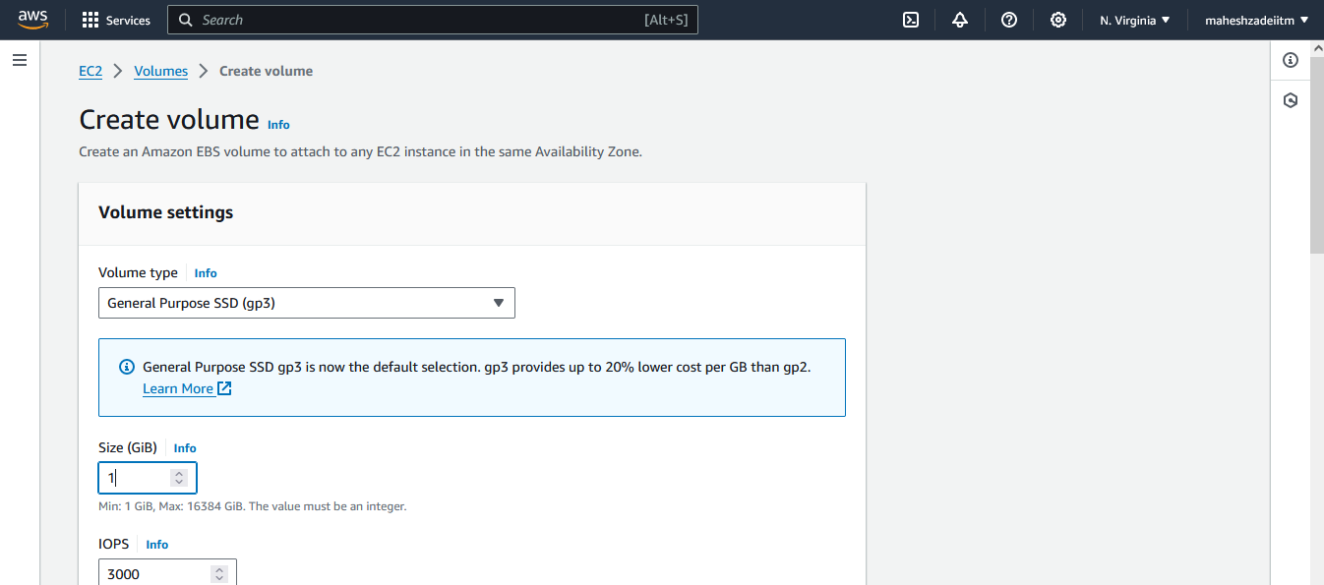

**Check the Availability Zone are Same while adding the Volume in EC2 Instance**

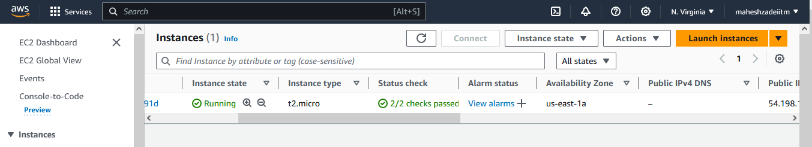

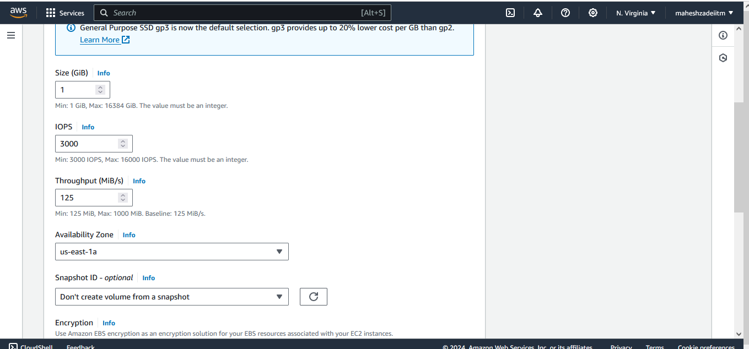

**Both are sam e**

**Click on create volume**

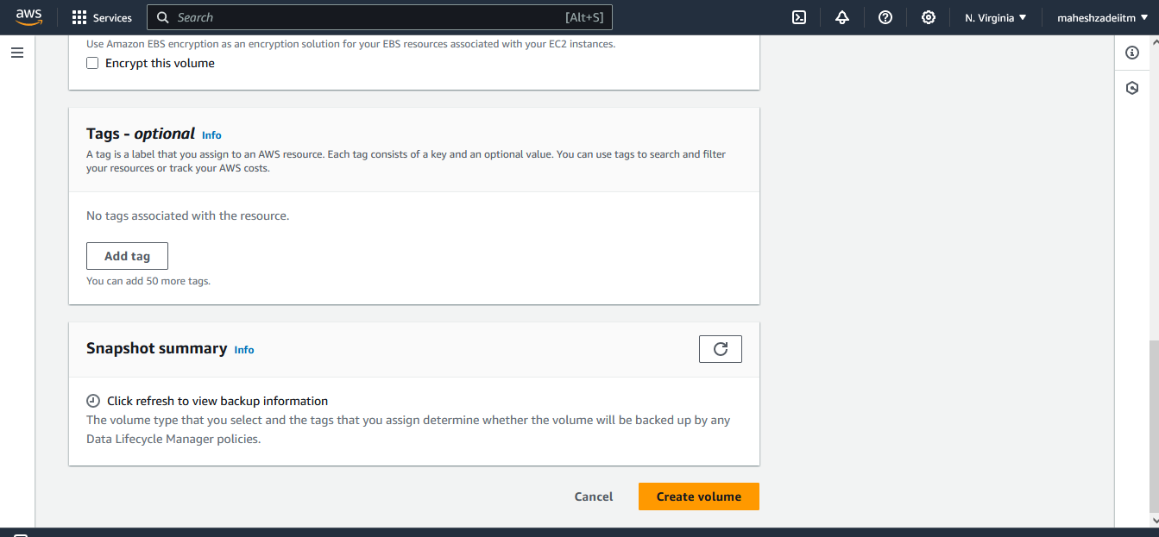

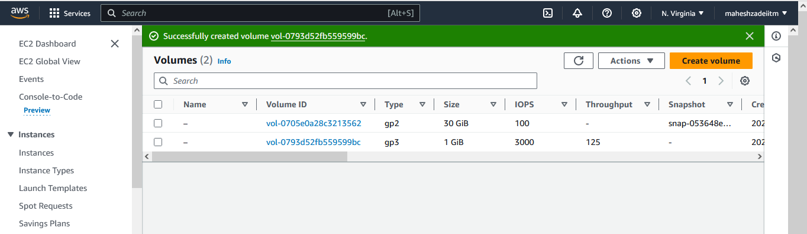

**Now attach volume to EC2**

**Go to action and click on attach volume**

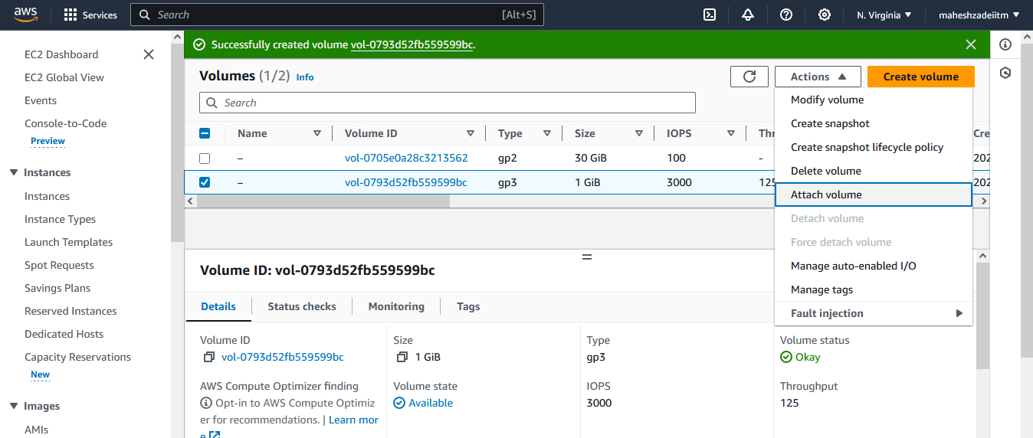

**Check instance ID**

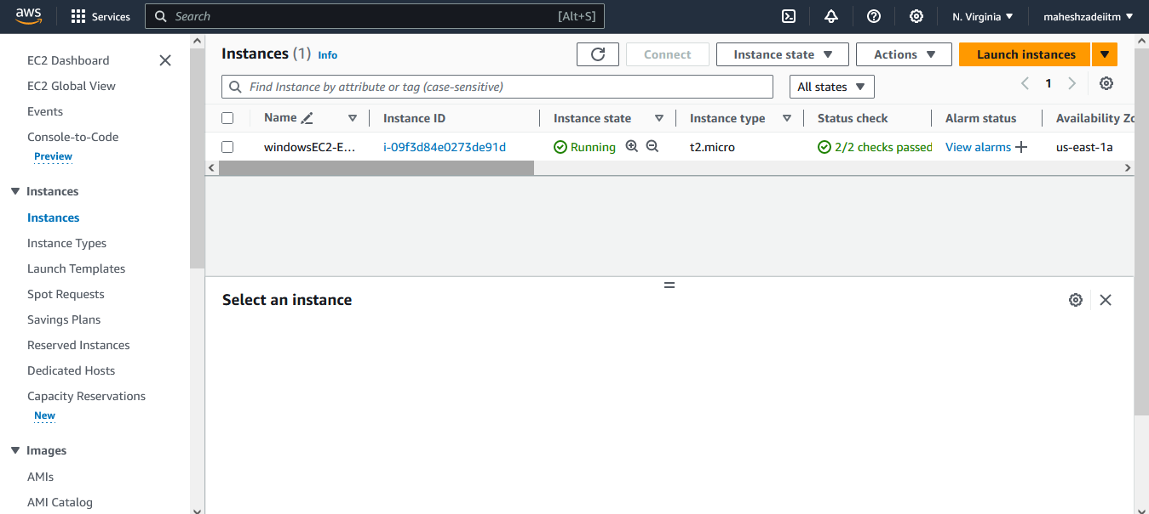

**Select instance and device name and then click on atta volume**

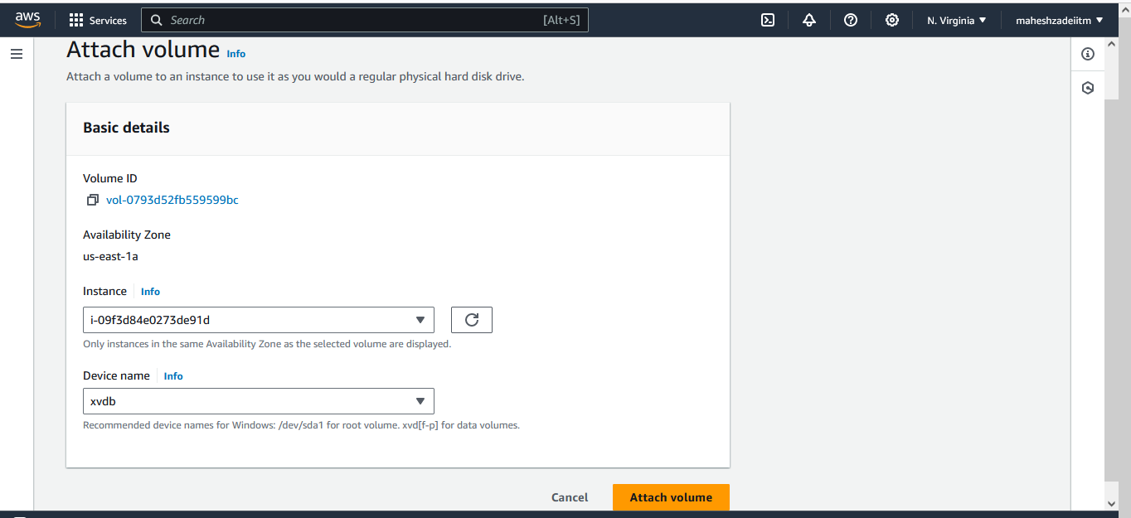

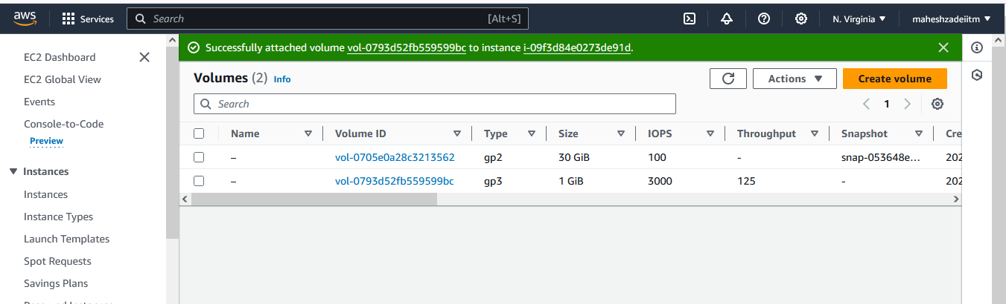

**Now go to EC2 login screen and attach the volune in VM**

**Go to Computer Management**

**And then disck management**

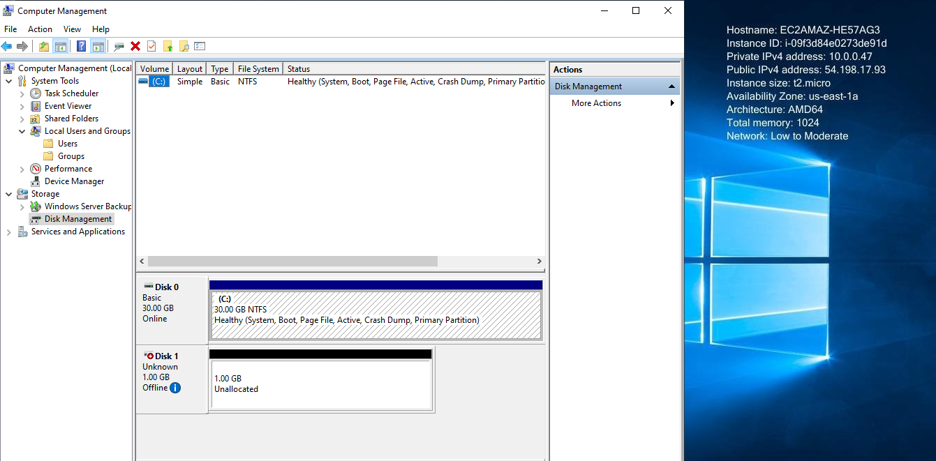

**Right click on disk 1 and make it online**

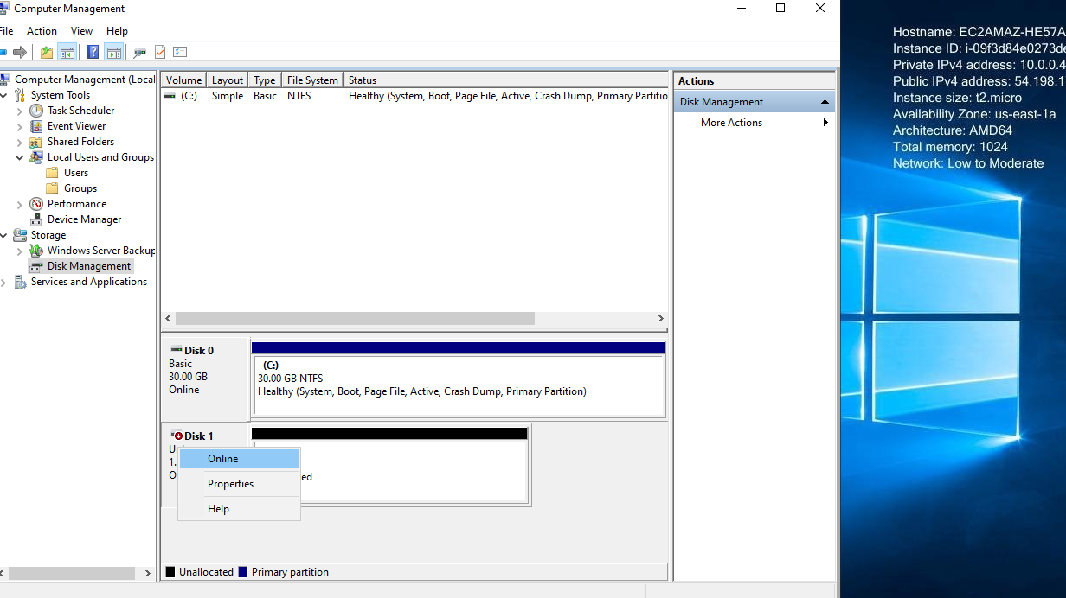

**Again clik on initialize the disk**

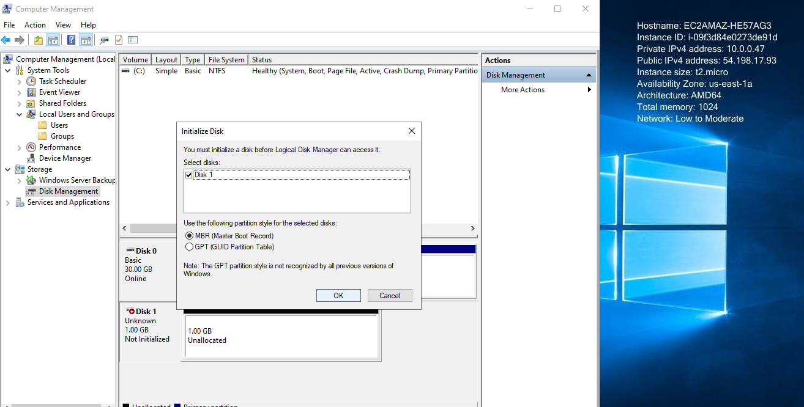

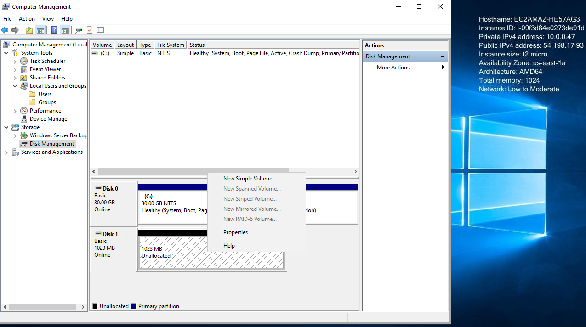

**Right click on new silpe Volume**

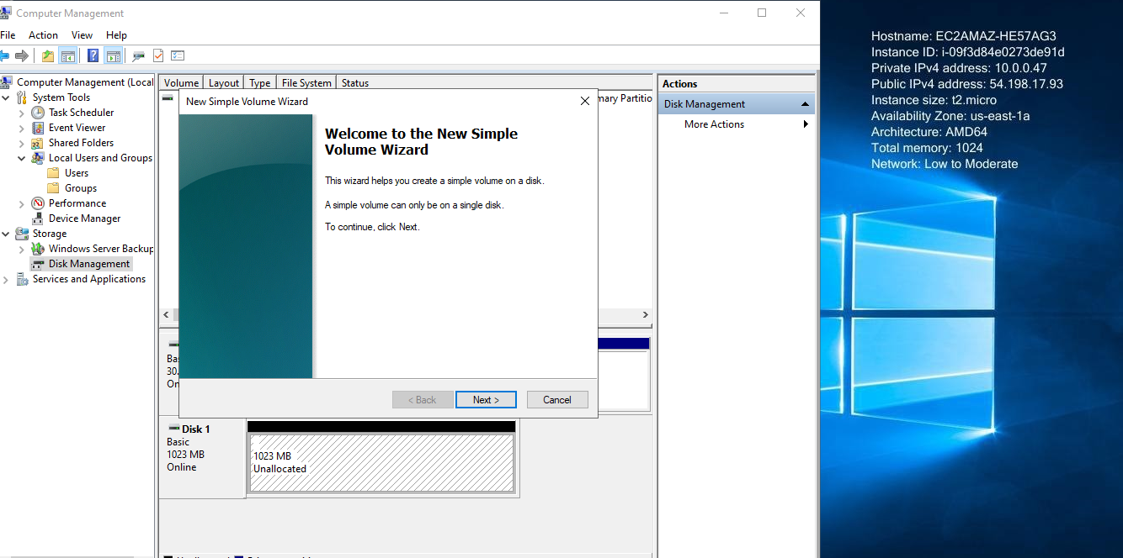

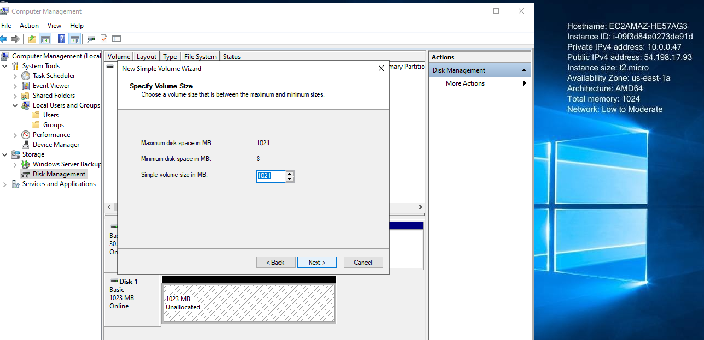

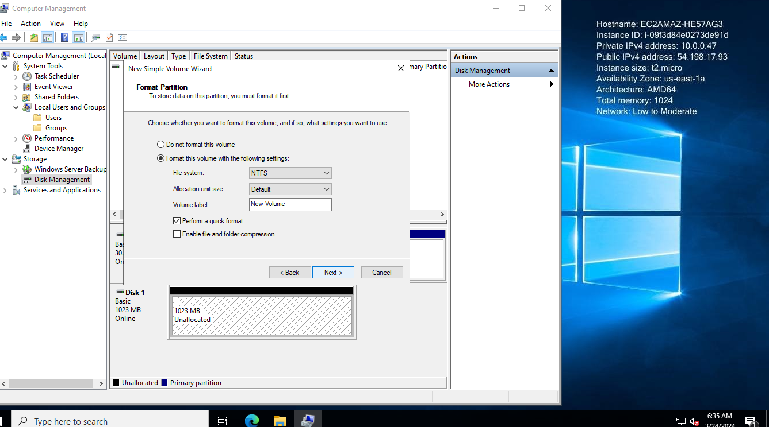

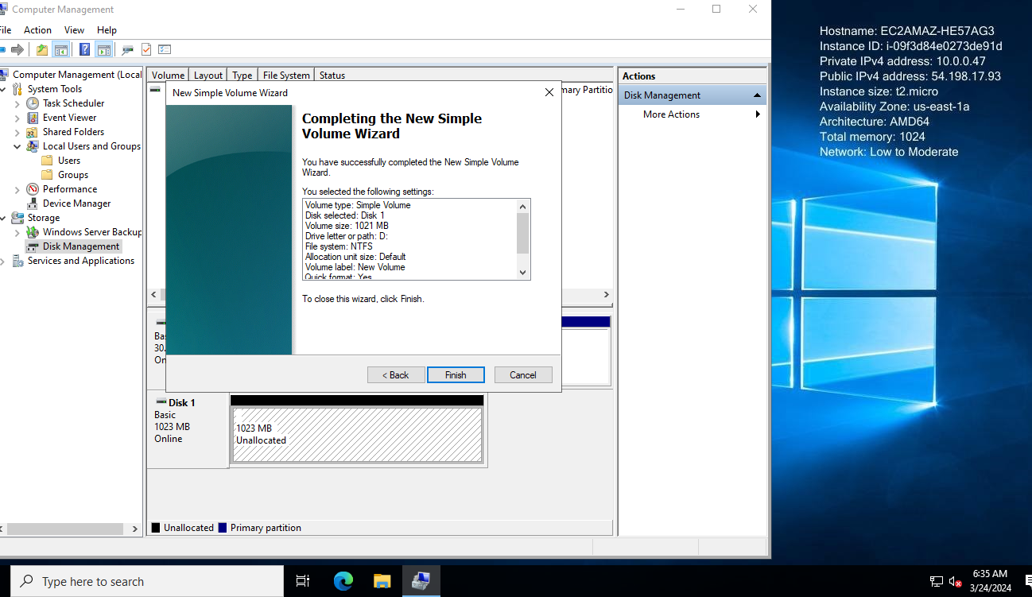

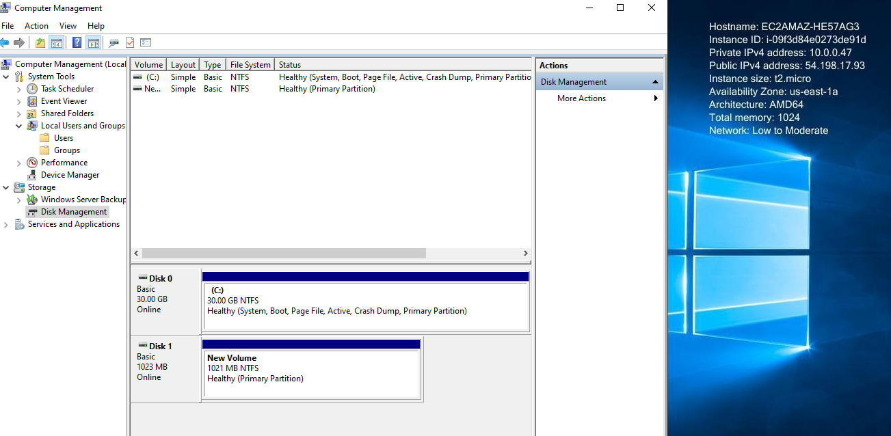

**Now 1 Gib Disk attached and working**

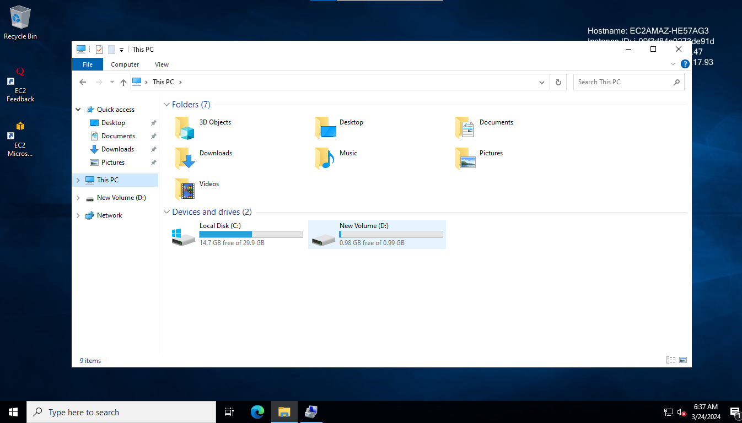

**Now upgrade the disk**

**Go to Aws Console and go to volune and select 1 Gib Volume**

**And upgrade to 2 GB**

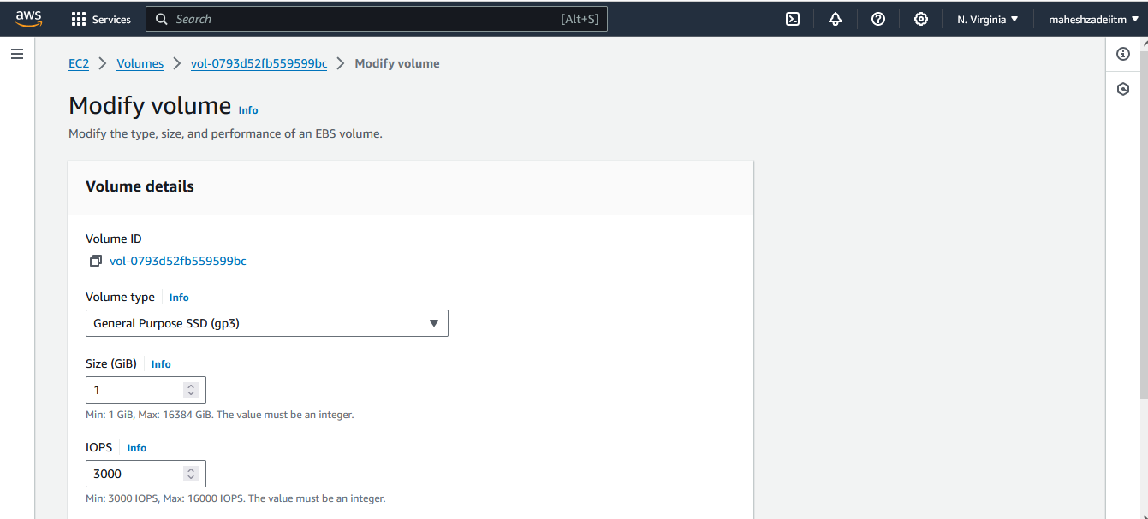

**Click on Modify Volume**

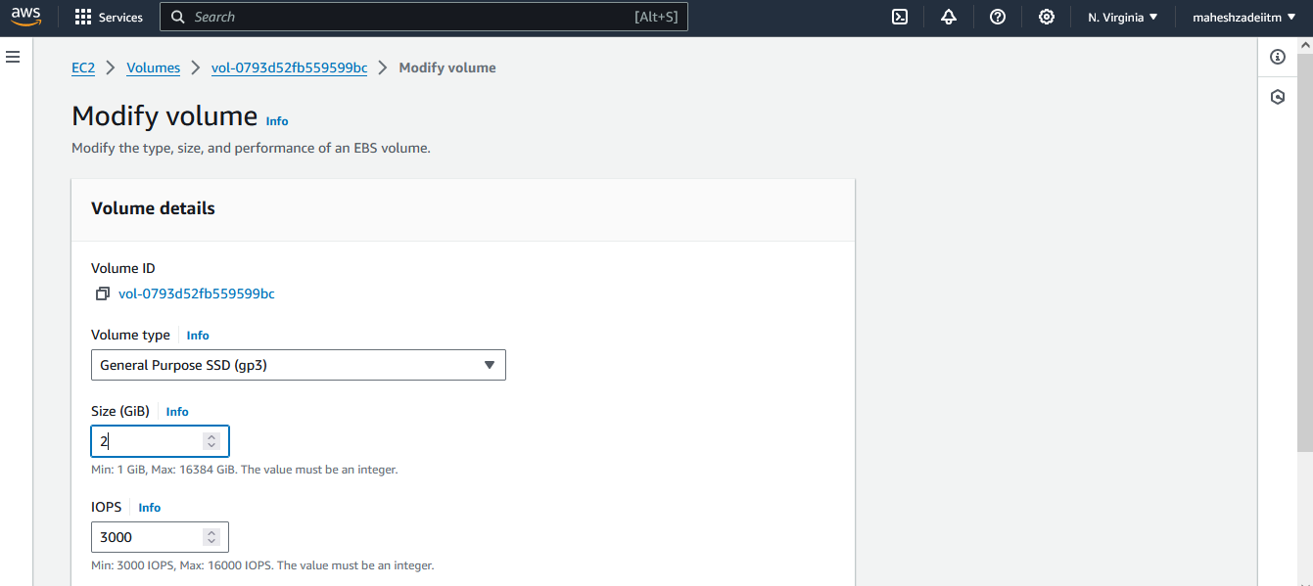

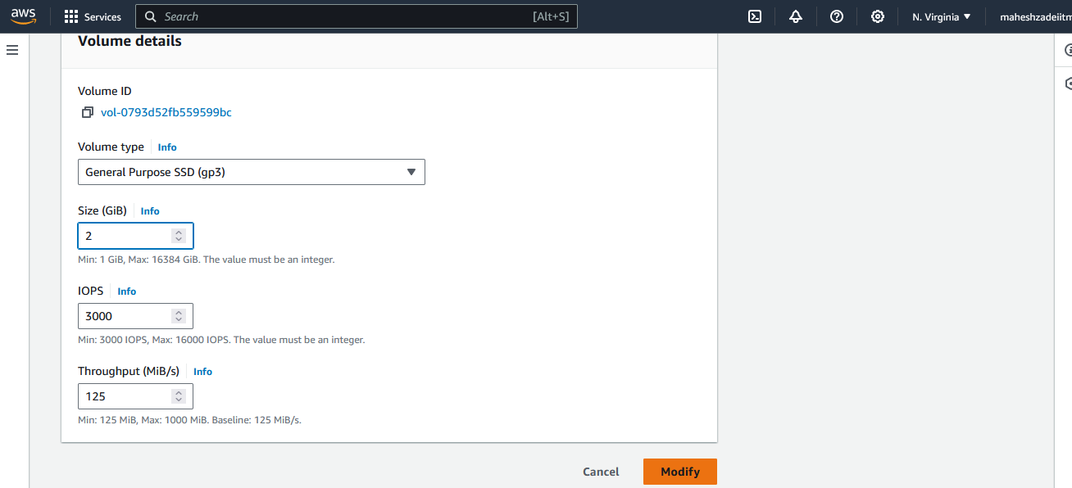

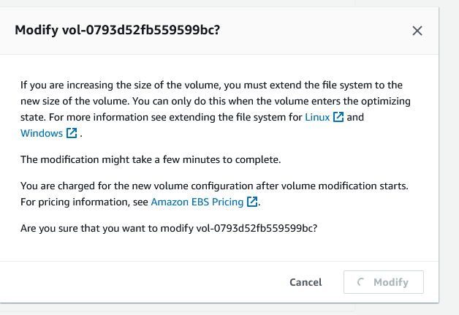

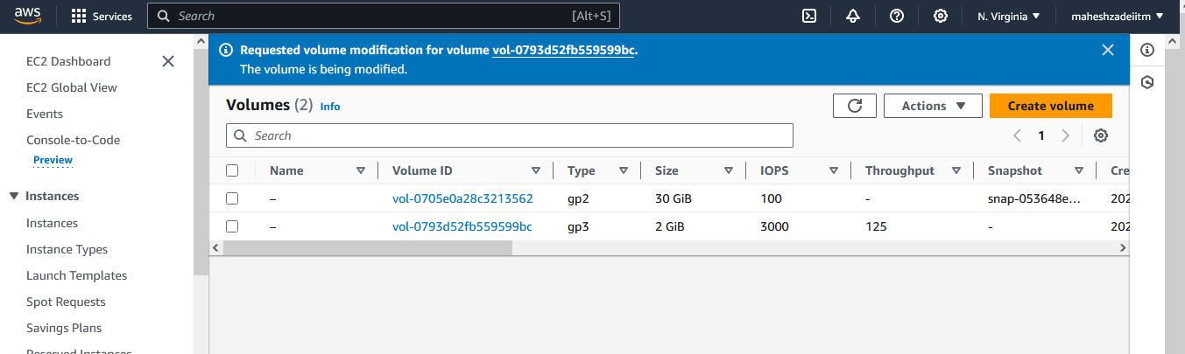

**Upgrade to 2 Gib but need to check in Ec2 Server inside**

**Go to EC2 Server**

**Computer Management and Disk Management**

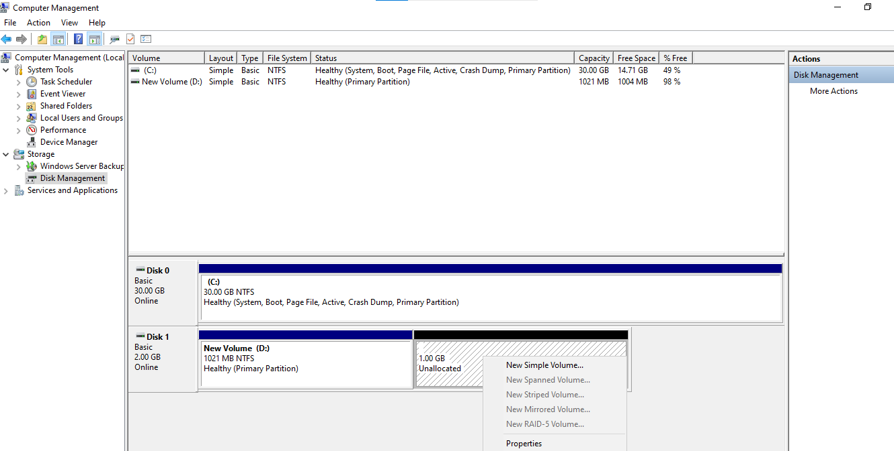

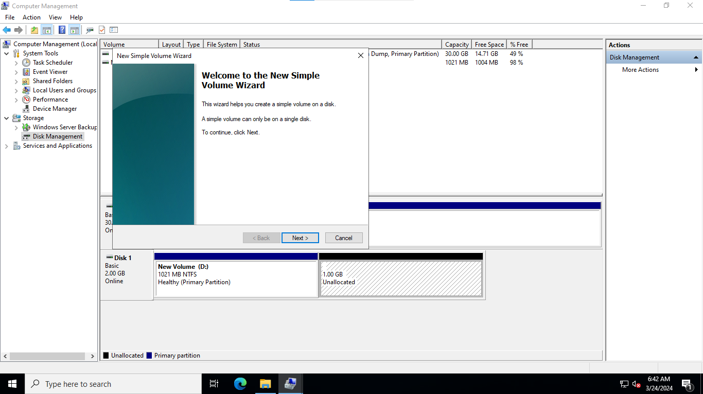

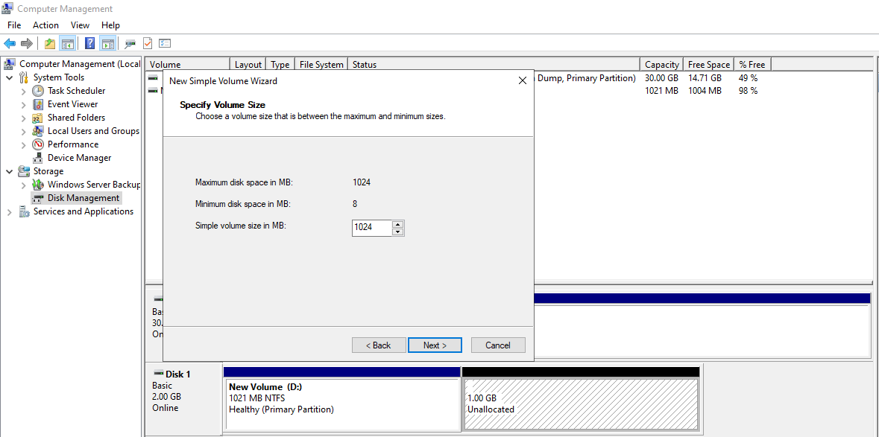

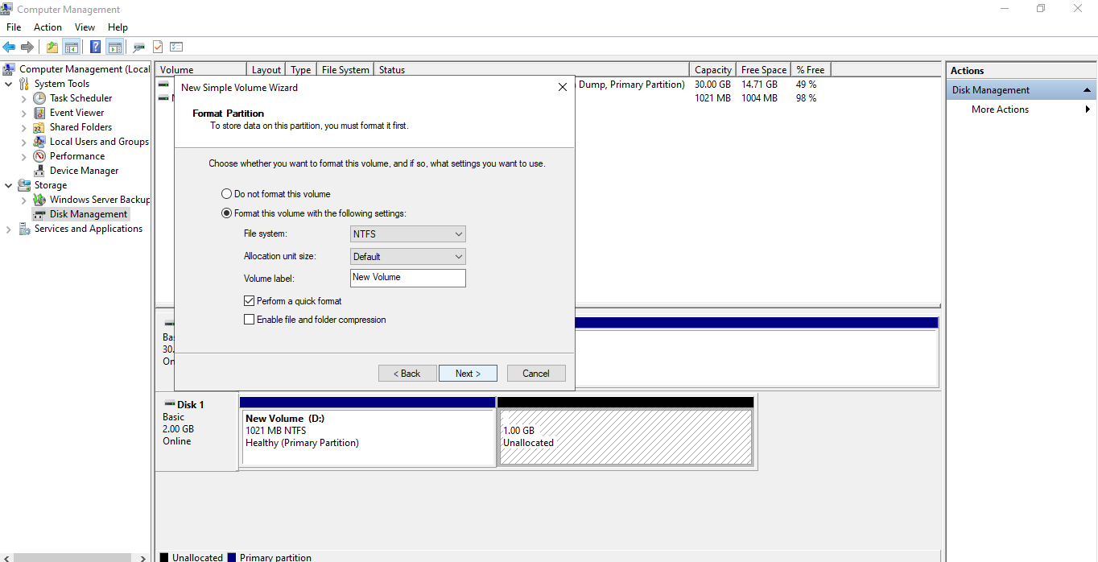

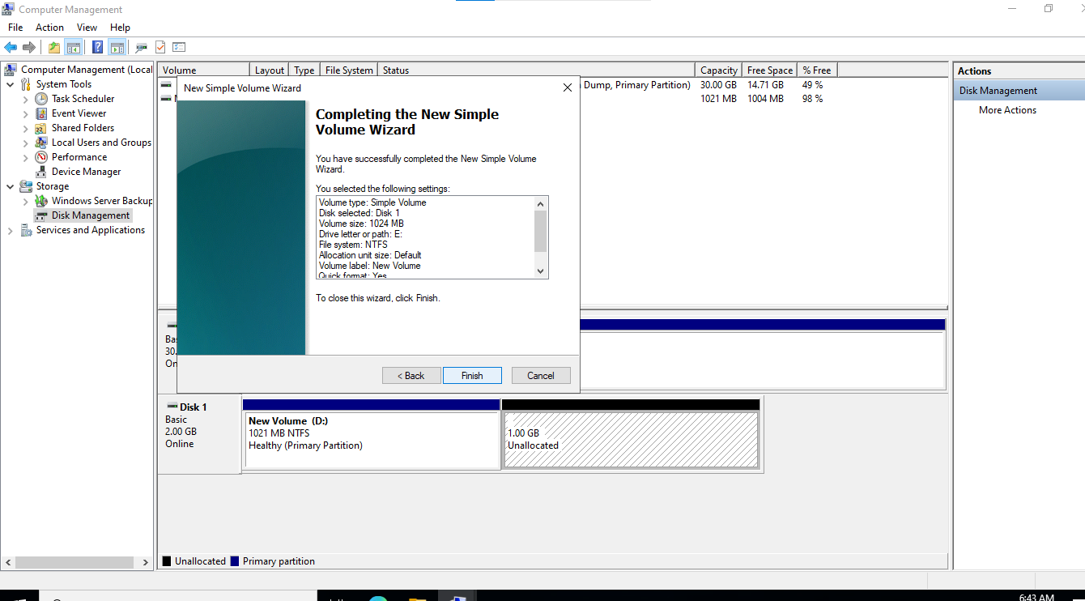

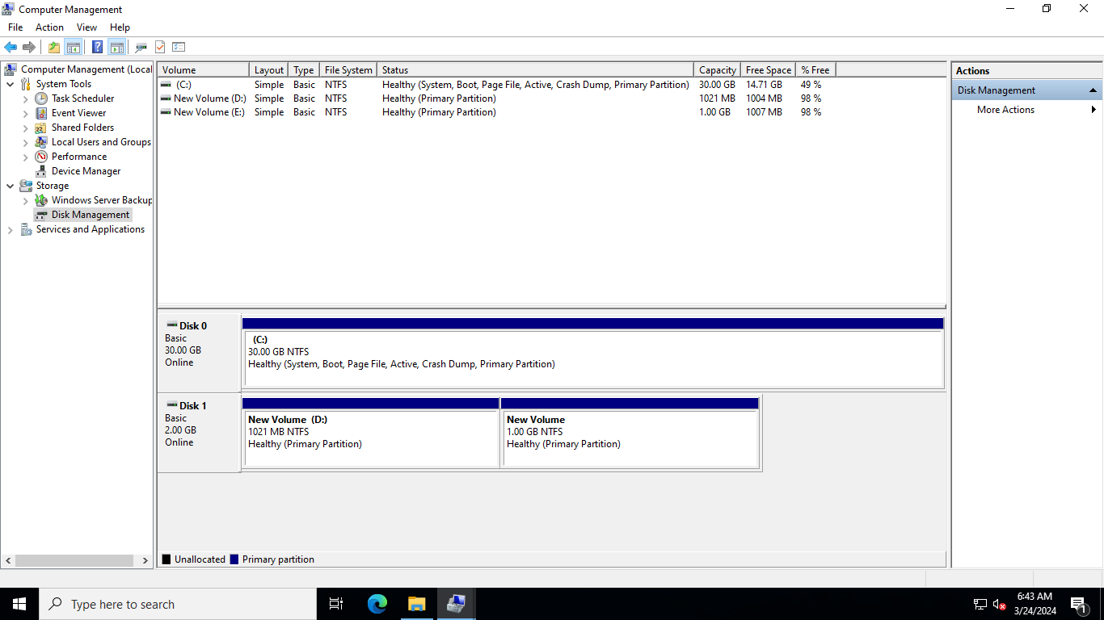

**Click on exted volume**

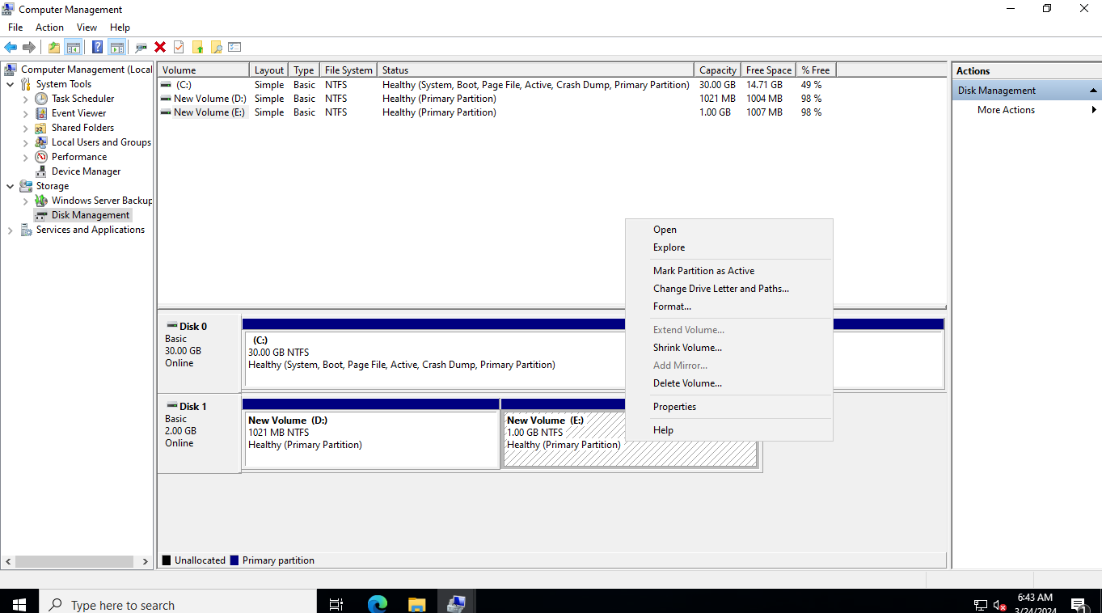

**Unable to extend the Volume but volume created**